South American white shrimp recirculating aquaculture system design aquaculture manual

**March 2025**

Nippon Daisho Agricultural Science and Technology Contracting Co.

Nippon Grintek Co.

This manual is based on the knowledge and technology summarized in the development of a South American white shrimp culture system in a pilot scale by Ojyo Agricultural Science and Technology Contracting Corporation and Grintek Japan Co.

Prepared by: Zhang Chi

Reviewer: Prof. Zhenya Zhang Prof. Zhenjia Zhang

March 2025

**catalogs**

Chapter 1 Introduction 1

1.1 Introduction to Factory Recirculating Aquaculture Systems 1

1.2 Feasibility and market prospects for farming 1

1.3 Purpose and scope of application of the manual 2

Chapter 2 Biological Characteristics and Culture Characteristics of South American White Shrimp (Litopenaeus vannamei) 3

2.1 Basic Biological Characteristics of South American White Shrimp (Litopenaeus vannamei) 3

2.1.1 Life history and life cycle 3

2.1.2 Environmental requirements for growth (temperature, salinity, pH, etc.) 3

2.1.3 Nutritional requirements and feed conversion efficiency 4

2.2 Characteristics of South American white shrimp culture in recirculating water system 5

2.2.1 Advantages and challenges of high-density farming 5

2.2.2 Water Quality Requirements and Maintenance Strategies 6

Chapter 3 Design of factory circulating water system 8

3.1 Basic components of a circulating water system 8

3.1.1 Water treatment equipment 8

3.1.2 Design and use of biofilters 11

3.1.3 Oxygen equipment 13

3.2 Layout design of the breeding workshop 14

3.2.1 Pool Design and Distribution 14

3.2.2 Water flow design and circulation patterns 16

3.2.3 Sewage Discharge and Recycling Systems 17

3.3 Other facility configurations 17

3.3.1 Light system 17

3.3.2 Ventilation systems 19

3.3.3 Backup power systems 20

Chapter 4 Construction of factory circulating water systems 22

4.1 Pre-construction preparation 22

4.2 Installation of equipment and layout of ancillary systems during construction 23

4.3 Equipment commissioning and operational testing 24

Chapter 5 South American white shrimp daily culture management 26

5.1 Water Quality Monitoring and Maintenance 26

5.1.1 Control of pH, salinity, temperature, dissolved oxygen 26

5.1.2 Frequency of water quality testing and data recording 29

5.2 Feeding management 30

5.2.1 Feed types and ratios 30

5.2.2 Time and method of feed feeding 31

5.3 Disease Prevention and Management 33

Chapter 6 Routine equipment maintenance 34

6.1 Cleaning and replacement of filtration equipment 34

6.2 Maintenance and management of biofilters 36

6.3 Inspection of piping, aeration and other equipment 37

6.4 Periodic cleaning and sterilization of the system 39

Chapter 7 Risk control and contingency measures 41

7.1 Identification and Handling of Common Faults 41

7.1.1 Water quality anomalies 41

7.1.2 Troubleshooting equipment failures and power use failures 42

7.2 Risk assessment and periodic safety drills 44

Chapter 8 Data recording and analysis 47

8.1 Criteria and content of data collection 47

8.1.1 Growth indicators (individual size, weight) 47

8.1.2 Water quality indicators (daily data) 49

Chapter 9 System upgrades and modifications 53

9.1 Adjustment of the system to increase farming densities 53

9.2 Adaptation of new designs 54

9.3 Environmental protection and energy conservation measures 54

9.3.1 Wastewater recycling 54

9.3.2 Energy conservation programs 55

bibliography 56

Chapter 1 Introduction

1.1 Introduction to Factory Recirculating Aquaculture Systems

Factory-based Recirculating Aquaculture System (RAS, Recirculating Aquaculture System) is a modern aquaculture method that realizes the recycling of water resources through highly efficient water treatment technology. The system consists of aquaculture tanks, biological filters, physical filters, gas exchange equipment, UV sterilizers, heating or cooling equipment and water quality monitoring systems. The core of the system is to maintain stable water quality through continuous water treatment and recycling, reduce environmental pollution in the aquaculture process, and improve the aquaculture density and output efficiency.

RAS has significant advantages over traditional pond or net box culture. Firstly, it saves a lot of water, and the water consumption is only 5-10% (1% for this technology) of the traditional aquaculture methods. Secondly, the system is highly controllable, optimizing the aquaculture environment by precisely regulating key parameters such as water temperature, dissolved oxygen, pH and nitrogen cycle. In today's climate change context, extreme weather phenomena are on the rise, and traditional aquaculture is easily constrained by local geography and climate, which may result in a single cooling or storm that can lead to a catastrophic disaster. Moreover, the closed mode of operation of RAS reduces the risk of pathogen transmission, thus significantly reducing the occurrence of aquaculture diseases.RAS is not dependent on the natural environment, and is suitable for efficient aquaculture in urban or environmentally sensitive areas, providing an important technological pathway for sustainable aquaculture.

1.2 Feasibility and market prospects for farming

The demand for aquatic products market is expanding rapidly in line with the global population growth and increasing demand for high quality proteins. In particular, the market potential for high value-added aquatic products such as South American white shrimp and salmon is considerable. However, the increasing depletion of marine capture resources, coupled with the multiple constraints of land, freshwater resources and environmental capacity of traditional aquaculture methods, has prompted factory-based recirculating aquaculture systems to become an important direction for the future development of aquaculture.

In terms of feasibility, RAS technology has matured. In recent years, with the continuous progress of biofiltration materials, sensor technology and automated control and artificial intelligence technology, RAS has performed impressively in commercial applications, laying a technical foundation for large-scale promotion. In addition, many countries around the world have introduced policies to support environmentally friendly aquaculture, which further promotes the development of RAS. At the same time, RAS can be flexibly designed according to different aquaculture species and scale requirements, and is applicable to a wide range of aquatic animals such as South American white shrimp, trout and salmon.

From the market outlook, the Food and Agriculture Organization of the United Nations (FAO) data show that aquatic products consumption will continue to grow in the next ten years.RAS as an environmentally friendly and efficient breeding mode, has become the focus of policy and capital attention, the future is expected to play an important role in industrial upgrading. South American white shrimp, for example, its global market size has exceeded 50 billion U.S. dollars, and has shown continuous growth. High-density, high-yield RAS technology will play a key role in alleviating the contradiction between supply and demand.

1.3 Purpose and scope of application of the manual

This manual aims to provide systematic and practical guidance for the design, construction, operation and maintenance of factory-based recirculating aquaculture systems. By summarizing the best practices and latest technologies in the industry, it helps readers to fully grasp the basic principles and key operation points of RAS, so as to improve the aquaculture efficiency, reduce the operation cost, and achieve the goal of sustainable development of aquaculture.

The manual is intended for beginners, farmers and investors. It is intended for beginners to gain a quick understanding of RAS principles, equipment and operational procedures; for farmers' technicians and managers to optimize their existing systems; and for investors to use as a reference guide to assess the potential of RAS projects. In addition, this manual is suitable for experimental or commercial projects engaged in high-density aquaculture of shrimp, fish and other aquatic animals, covering the planning, implementation and management of small-scale experimental systems to large-scale commercial projects.

This manual involves some key technical parameters, is limited to internal use, is strictly prohibited to external leakage.

Chapter 2 Biological Characteristics and Culture Characteristics of South American White Shrimp (Litopenaeus vannamei)

2.1 Basic Biological Characteristics of South American White Shrimp (Litopenaeus vannamei)

2.1.1 Life history and life cycle

South American white shrimp (*Litopenaeus vannamei*) adaptability, natural habitat for the muddy seabed, water depth 0～ 72m, can grow in salinity 0.5～ 35 ‰ of the water, 2～ 7cm of juvenile shrimp, the salinity of the allowable range of 2～ 78 ‰. Can survive in the water temperature of 6～ 40 ° C, the growth of water temperature of 13～ 40 ° C, the optimal growth of water temperature of 22～ 30 ° C. The high temperature tolerance limit of 43.5 ° C (asymptotic amplitude), the ability to adapt to low temperatures is poor, the water temperature is lower than 18 ° C, its feeding activities are affected, 9 ° C or less when the side of the water lying on the bottom. Requires fresh water quality, dissolved oxygen above 5 mg/L, the lowest dissolved oxygen that can be tolerated is 1.2 mg/L. Adapted pH is 7.5～ 8.5, and low ammonia nitrogen content is required. Can live in seawater, brackish and freshwater. Newly hatched planktonic larvae and juvenile shrimp feed and grow in low-salt waters (4～ 30‰) in the sea area near estuaries rich in bait organisms and in shallow waters with soft muddy substrates in coastal lagoons, and begin to swim back offshore when their body length reaches an average of 12 cm, and a large number of them return to the sea at the lowest ebb of a month, which coincides with the time of the full moon and the new moon.

Artificial aquaculture conditions, the daytime are generally quiet at the bottom of the pool, into the twilight after the frequent activities. South American white shrimp feeding for omnivorous. Juveniles to zooplankton neritic larvae for food; juvenile shrimp in addition to ingesting zooplankton, also ingested benthic animal life larvae; adult shrimp to live or dead plants and animals and organic debris for food, such as worms, various aquatic insects and their larvae, small mollusks and crustaceans, algae and so on. Under artificial feed conditions, the nutritional requirements of the feed are low, and the crude protein content of the feed of 25～ 30% can meet its nutritional requirements. The shrimp has the habit of mutual predation, and with the growth of this habit is more obvious. South American white shrimp for the open type of seminal vesicle type. Its reproductive habits are different from those of the Chinese shrimp. Male and female shrimp gonads fully mature before mating. Mating, the male shrimp discharge sperm pods adhering to the female shrimp thorax between the third and fourth pairs of footsteps (spermatophore position) a few hours after mating, the female shrimp began to spawn, the sperm pods at the same time to release sperm, in the water to complete fertilization.

2.1.2 Requirements for growing environment in artificial culture (temperature, salinity, pH, etc.)

South American white shrimp (Litopenaeus vannamei) is suitable for growth in the water temperature of 26-32 ° C, the average daily temperature change is best not to exceed 2 ° C; tolerance of salinity range of 0.5-40 ‰, the best growth salinity of 10-35 ‰, the adult shrimp daily salinity change is best not to exceed 3; pH should be maintained between 7.5-8.5 and try to stabilize fluctuations of not more than 0.5. variation should preferably not exceed 3; pH needs to be maintained between 7.5-8.5 and as stable as possible, with daily fluctuations of no more than 0.5. Dissolved oxygen concentration should be no less than 5 mg/L, and ammonia nitrogen (free ammonia) and nitrite nitrogen concentration should be less than 0.05 mg/L and 0.1 mg/L, respectively (experience in practice, ammonia and nitrite not more than 1 ppm) to prevent poisoning. Maintaining the alkalinity and hardness of the water at 80-150 mg/L and 100-200 mg/L (in terms of CaCO3)helps stabilize pH and promotes the development of shelling. Appropriate use of calcium, magnesium, potassium and trace element supplements. Lighting is moderate and the substrate needs to be clean to avoid accumulation of organic matter producing harmful substances. Density of culture is selected according to the system, 20-50 tails/square meter for traditional model and up to 100-300 tails/square meter for high density recirculating aquaculture (RAS). The present high-density recirculating aquaculture system explores the feasibility of culture densities of 1,000 fish/m2.

2.1.3 Nutritional requirements and feed conversion efficiency

South American white shrimp on the nutritional needs of a more comprehensive, involving protein, fat, carbohydrates, vitamins and minerals and other aspects. Reasonable nutritional supply is the key to its efficient growth, enhance immunity and improve the survival rate, while the feed conversion efficiency (Feed Conversion Ratio, FCR) is an important indicator of the level of feeding management.

Protein is the main source of nutrition for South American white shrimp for growth, shell removal and tissue repair. Feed protein content generally needs to be maintained between 30-40%, with higher protein requirements under high-density culture conditions. Protein sources include fishmeal, soy protein and other plant proteins, but attention needs to be paid to amino acid balance, especially lysine and methionine supplementation. Unbalanced amino acid structure will reduce protein utilization and lead to lower feed conversion efficiency.

Fat is an important source of energy for shrimp, and the fat content of feed is typically 5-8%. South American white shrimp have a high demand for essential fatty acids (e.g., eicosapentaenoic acid EPA and docosahexaenoic acid DHA), which are essential for their growth and immune function. Fish oil and algae are the main sources of high quality fatty acids, but vegetable oils can be partially substituted to reduce costs.

Carbohydrates mainly provide energy for the South American white shrimp, feed is generally added 10-20% of carbohydrates. Shrimp have a limited ability to utilize carbohydrates, and too much can lead to a burden on sugar metabolism, thus affecting health. Through a rational mix of starchy ingredients (such as corn and wheat), can effectively improve energy utilization efficiency and reduce feed costs.

Vitamins (e.g. vitamin C, vitamin E) play an important role in antioxidant, immune regulation and growth promotion, and need to be scientifically added to the feed according to the formula. Minerals (e.g. calcium, phosphorus, magnesium, potassium) are indispensable for shrimp shell formation and osmotic pressure regulation, especially in low-salinity culture conditions, additional calcium, magnesium and potassium supplements are needed.

The feed conversion efficiency (FCR) of South American white shrimp (Litopenaeus vannamei) is usually 1.2-1.8, i.e., 1.2-1.8 kg of feed is needed for every 1 kg of weight gain. In high-density recirculating water culture, FCR can be reduced to 1.0-1.2 due to good environmental control.Factors affecting FCR include feed formulation, processing quality, feeding practices and water quality management. High-quality feeds can significantly improve FCR and reduce farming costs, as well as reduce environmental pollution.

The nutritional requirements of South American white shrimp are closely related to feed conversion efficiency. Scientific nutrient supply and efficient feeding management can not only promote healthy growth of shrimp, but also realize higher economic benefits and environmental sustainability.

2.2 Characteristics of South American white shrimp culture in recirculating water system

2.2.1 Advantages and challenges of high-density farming

High-density culture of South American white shrimp (*Litopenaeus vannamei*) in recirculating aquaculture systems (RAS) is regarded as a trend in modern aquaculture due to its high resource utilization efficiency and environmental friendliness. In practice, this model has both significant advantages and many challenges.

RAS through biological filtration and physical treatment technology to achieve water recycling, greatly reducing the amount of water and sewage, compared with the traditional pond culture saves more than 90% (99.9% of this technology) of the water resources, especially suitable for water scarcity or environmental protection requirements of strict areas. The temperature, salinity, dissolved oxygen, pH and other key parameters in the system can be precisely controlled to avoid the impact of drastic changes in the external environment on the growth of shrimp. This stabilized environment significantly increases the growth rate and survival rate of the shrimp. Due to the isolation from the external water body, RAS effectively reduces the risk of pathogen invasion, especially in the culture area where viruses (such as white spot syndrome virus) are prevalent, this model can significantly reduce the probability of disease outbreaks.

In RAS, farming densities of 100-300 tails per square meter or even higher can be realized, and the production per unit area far exceeds the traditional farming mode, providing a feasible solution to the problem of land resource constraints and increased production demand. RAS can reduce the discharge of ammonia nitrogen, nitrite and organic matter in the aquaculture wastewater through highly efficient solid waste capture and water purification, thus Reduces environmental pollution from farming.

The initial investment in RAS is large, mainly for equipment purchases such as biological filters, pumps, oxygenation equipment and water quality monitoring systems. During operation, energy consumption (e.g. pump operation and oxygenation) and maintenance costs are high, requiring high financial and technical support. High-density aquaculture has harsh water quality requirements, requiring real-time monitoring and regulation of key indicators such as ammonia nitrogen, nitrite, dissolved oxygen and pH. Deteriorating water quality can quickly affect shrimp health and reduce survival rates if not treated in a timely manner. Although RAS reduces the invasion of external pathogens, in the event of disease within the system, it can lead to extensive losses due to the high culture density and rapid spread of disease. Therefore, biosecurity management and disease prevention and control are extremely important.

Operating and managing a RAS requires specialized skills in areas such as equipment maintenance, culture management, and water quality control, and additional training may be required for general farm personnel.

High-density aquaculture of South American white shrimp in recirculating aquaculture systems has significant advantages such as water conservation, high yield and environmental protection, but it also faces challenges in terms of technical requirements, cost inputs and water quality management. With the decline in equipment costs and the maturity of technology, this model is expected to become the mainstream of aquaculture in the future. In order to improve efficiency, the challenges should be met by optimizing system design, upgrading aquaculture technology and strengthening management capabilities to achieve sustainable development.

2.2.2 Water Quality Requirements and Maintenance Strategies

In a factory-based recirculating aquaculture system (RAS), the stability and suitability of water quality is critical to ensure healthy growth and efficient production of farm animals. The following are common water quality parameters required for RAS and maintenance strategies.

|  |  |  |  |
| --- | --- | --- | --- |
| **Table 1 Water quality requirements** | | | |
| **norm** | **Reasonable range** | **outlier** | **Treatment** |
| Dissolved oxygen, mg/L | > 4.0 | ≤ 4.0 | * Check that the aeration facilities are in good working order; * The water in the pool is too turbid resulting in increased oxygen consumption by microorganisms; * Whether the density of culture in the pool is too high. |
| pH | 7.6~8.4 | / | * Monitor pH diligently, and if it is below 7.6 or has had a continuous drop in recent days, splash appropriate amounts of lime to maintain pH above 8.0; * Excessive algal blooms can affect pH stabilization. |
| Ammonia nitrogen, mg/L | < 0.1 | > 0.1 | * Check the working condition of the biopool; * Water change. |
| Nitrite nitrogen, mg/L | < 0.1 | ≥ 0.1 | * Check the working condition of the biopool; * Water change. |
| Nitrate nitrogen, mg/L | / | / | * Generally not higher than 200 mg/L. |
| Temperature.℃ | 26~31 | < 24. | * Feeding is affected at temperatures below 24 degrees Celsius; some shrimp may die at temperatures below 22 degrees Celsius; shrimp vigor is reduced at temperatures below 20 degrees Celsius, with daily mortality. |
| Salinity, ‰ | / | / | Can be lightened to 3‰ |

Chapter 3 Design of factory circulating water system

3.1 Basic Components of the Circulating Water System of the Technology

3.1.1 Water treatment system

Water treatment system is the core component of circulating water aquaculture system, good water treatment is the key to ensure the success of aquaculture. The water treatment system generally consists of ① aquaculture tank unit; ② physical filtration unit; ③ bioreactor unit. Each unit contains the following main components: dirt collection device, physical filters, biological filters, circulating water pumps, circulating water fittings and so on.



**Figure 1 Schematic diagram of the circulatory system as a whole**

The purpose of the fouling collection device is to quickly and efficiently collect the solids (including large quantities of feces and food scraps, etc.) that are constantly being generated in the culture. These solids are generally considered to contain more than 70% of the pollution in the system, and the removal of feces and food scraps, etc. can greatly reduce the treatment load on the biofilter. If these solids are not removed from the aquaculture system in a timely manner, they can lead to a rapid increase in the amount of nutrients (ammonia, nitrogen, etc.) dissolved in the water column over time, increasing the treatment load on the biofilter. It will also lead to turbidity in the water body, and even a large number of microorganisms will multiply in the pool, which will further lead to vicious events such as the reduction of dissolved oxygen in the pool and the odor of the water body, and ultimately lead to the failure of aquaculture. For example, in this aquaculture trial, the residual feed in the aquaculture pond started to turn into ammonia nitrogen after the 4th day, and the ammonia nitrogen conversion was completed after one week. The removal of solids depends on a good dirt collection device, and this manual summarizes the solution of using a "fish toilet" to collect dirt.

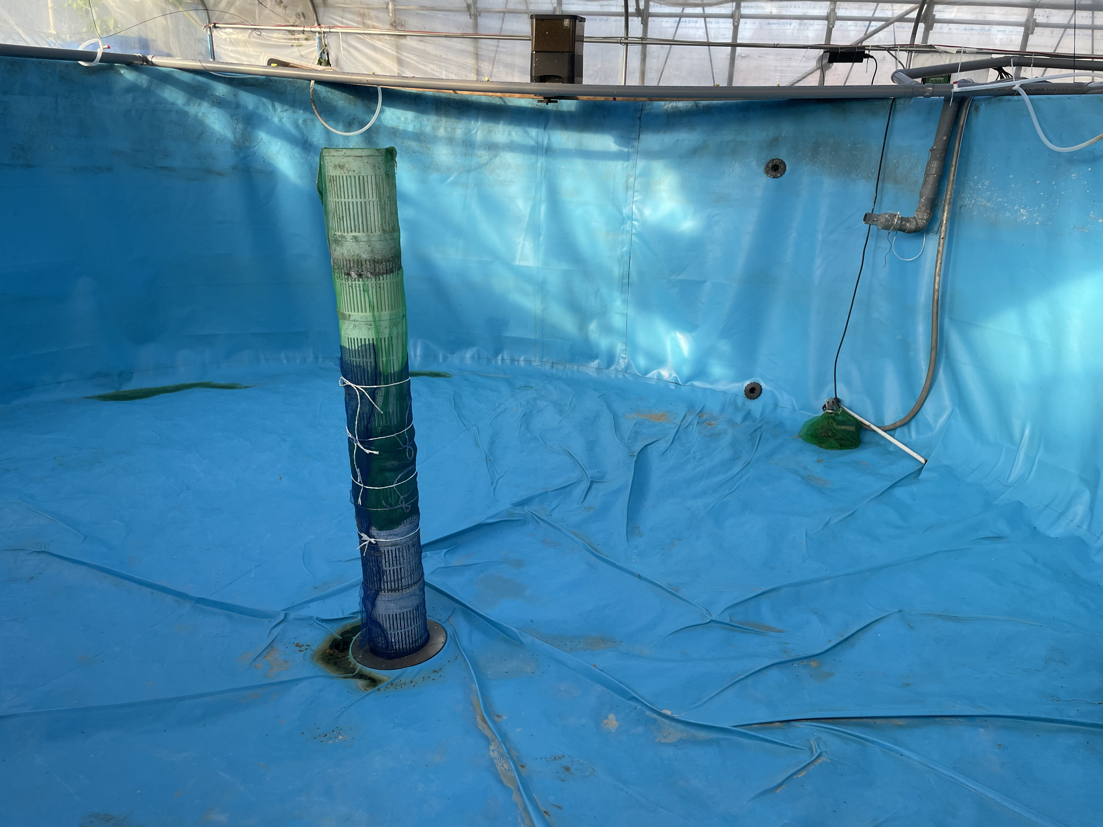 **Fig. 1 Fish toilet and dirt filtering pipe at the bottom of the aquaculture tank**

A physical filter is a device that separates solids such as collected manure and food scraps from liquids and removes solid contaminants from the farming system. This manual was written based on the use of backwashing microfilters for physical filters. Depending on the pore size of the wrapped filter mesh, microfilters can generally filter out solids larger than 75 µm (using a 200 mesh mesh screen). Backwash microfilter models are generally identified by the maximum water flow rate that can pass through the screen, e.g., 8 ton/h means the maximum amount of water that can pass through the backwash microfilter (screen) under clean water circulation conditions is 8 tons per hour. Generally, according to a safety factor of 1.5 to 5 times, a larger model of microfilter is selected based on the circulating flow rate of the pond water in the aquaculture pool. The following table shows an example of the design of a microfilter model for a standard 20-ton pond.

|  |  |
| --- | --- |
| **Table 2 Design cases for microfilter flow rate and effective volume of culture ponds** | |
| **Pond Diameter** | 5 m |
| **Pool height** | 1 m |
| **Effective volume of breeding tank** | 19.6 m3 |
| **Design of pond water circulation flow rate** | 10 tons of circulation per hour |
| **safety factor** | 3 (3 to 10) |
| **Microfilter Model** | 3*10=30 ton/h |

Case A: The test measured that when the automatic backwashing of a 10 ton/h microfilter was turned on, the discharge was 0.25 liters per time, and the amount of dry weight dirt discharged was 1.27 grams per time. During the maximum discharge period in the aquaculture process, the automatic backwashing is once every 5 minutes, and 288 times per day, which can discharge 365.8 grams of dry weight solid waste. If according to the maximum aquaculture production of 20 kg per square meter, feed feeding for shrimp weight of 3%, per square meter per day into the feed amount of 0.6 kg, at this time the amount of sewage discharged for 0.18 kg (30% of the weight of the feed), taking into account the collection of sewage efficiency and microfilter sewage efficiency of 70% of the dirt, per square meter per day, can be discharged 0.126 kg of sewage, i.e., 10 ton / h of microfilter can meet the 2.9 square meters of aquaculture demand; if the backwash interval is adjusted to 2 minutes, so that the microfilter can meet the demand of 7.3 square meters. The smaller tank in this test is 7 square meters (1 meter water depth), and the 10 ton/h microfilter can meet the peak demand of aquaculture sewage discharge.

The circulating water pump adopts DC power supply pump, which is convenient to adjust the flow rate according to the actual situation. The maximum flow rate should be greater than or equal to the design of the breeding pool water circulation flow. Breeding pool water circulation design flow rate according to every 1 to 2 hours will be the entire pool water change once. Generally in accordance with the safety factor of 1 ~ 1.2 to choose the corresponding flow rate of the pump. The pump is the power part of water circulation, to ensure that the water of the whole system flows through the dirt collection device, physical filters, biological filters, to complete the separation and decomposition of dirt. Therefore, a reliable and durable circulating water pump should be used. If necessary, there are spare parts available. The circulating water pump needs to work almost uninterruptedly for 24 hours, and the power consumption needs to be considered appropriately. The technical parameters for the selection of the pump head for the actual operation of the head of 1.5 times the best.

Circulating water pipe fittings are made of PVC pipe, and the joints are firmly bonded with PVC special bonding glue. According to the standard bonding operation bonding fittings, to avoid bonding is not firm to lead to parts of the leakage under stress. The bonding head should be clean and dry, you need to use clean manipulation tools to avoid the bonding part of the dirt affect the bonding degree of firmness. Refer to the instructions of the bonding adhesive, press the adhesive for several seconds to several minutes (depending on the ambient temperature and pipe diameter) to ensure that the adhesive is dry and firmly bonded. Avoid twisting the bonded parts during the pressing period. Please check that the bonded parts are firm, especially the hidden position parts, not easy to maintain the position parts, if there is not firmness, wipe clean and re-bonding.

3.1.2 Design and use of biofilters

The biofilter is the core component of the entire recirculating aquaculture system and water treatment system. The main principle of biofilter is to utilize microorganisms to treat the harmful compounds produced during the aquaculture process. It mainly uses nitrification reaction to convert ammonia (NH3/NH4+ ) and nitrite (NO2⁻ ) into nitrate (NO3⁻ ), so that the water quality indicators are maintained at a level that allows for the healthy breeding of aquatic organisms.

Nitrogen compounds (e.g., ammonia nitrogen, nitrite nitrogen, nitrate nitrogen) are common in aquaculture systems, and are toxic to South American white shrimp in the order of toxicity intensity > nitrite nitrogen > nitrate nitrogen. The main source of toxicity of ammonia nitrogen is free ammonia (NH3), the proportion of which increases at high pH and high temperatures, and which is so intensely toxic that it can trigger serious physiological problems by interfering with cellular ionic homeostasis and metabolic functions. When the concentration of free ammonia reaches more than 0.1 mg/L, it will lead to reduced feeding and abnormal behavior of shrimp, while more than 0.5 mg/L may be fatal. Ammonium ions (NH₄+ ) are less toxic, but can still affect shrimp growth and health with prolonged exposure or at high concentrations. Nitrite (NO₂-) is toxic mainly in the blood system. It binds to shrimp hemocyanin to produce methaemoglobin (MetHb), which reduces oxygen transport capacity and leads to hypoxia. In addition, nitrite triggers oxidative stress and damages cell membranes and DNA.Nitrite toxicity is enhanced in low salinity environments.Shrimp are usually safe at concentrations below 1 mg/L, but may show signs of hypoxia and die when concentrations exceed 5 mg/L.Nitrate is also toxic to the blood system, where it binds to hemocyanin to produce high iron hemocyanin (MetHb), which reduces oxygen transport capacity. Nitrate (NO3⁻ ) is the least toxic and has chronic effects on shrimp primarily through increased osmolarity. Although shrimp can tolerate higher concentrations of nitrate (96-hour LC50 typically ranges from 96~ 500 mg/L), chronic exposure to concentrations above 100 mg/L may result in reduced immunity. High salinity is effective in mitigating the toxicity of nitrite and nitrate, so appropriate adjustment of salinity in culture management can help reduce the effects of nitrogen compounds.

The size of the biofilter should be determined by the density of the culture and the type of water treatment carrier. According to the biomass density of aquaculture , the general biofilter area generally accounts for 20~60% of the area of the aquaculture tank. This time, the production of South American white shrimp is 15 kg / square meter, biofilter accounted for 5~10% of the area of the breeding tank, basically can meet the maximum density design needs. According to the design principle, a larger area of biofilter can be used according to the insurance coefficient of 1.2~ 2.0 to eliminate the risk of water quality caused by fluctuations in microbial vitality of nitrifying bacteria and other microorganisms. Typically 30% of the biofilter volume needs to be filled with biocarriers. Depending on the type of biocarrier used, filling and microbial domestication need to be adequately and rationally arranged taking into account the commercial cycle arrangement of aquaculture and changes in different salinities. The domestication of the bio-carriers in this culture trial was 10 days with good results.

Case B: Based on a maximum culture yield of 20 kg per square meter with feed feeding at 3% of shrimp weight, the daily feed input per square meter is 0.6 kg, at which time the amount of feces produced is 0.18 kg (30% of feed weight). If the physical filtration rate unit can discharge 70% of the feces, 30% of the feces dissolved ammonia nitrogen needs to be treated by the biological treatment unit. At 30% protein content in the feed, the manure contains 16.2 grams of protein, which translates to 2.6 grams of ammonia nitrogen. If the pond area is 7 square meters, the total ammonia nitrogen to be removed by the biological treatment unit is 18.1 grams per day.

The ammonia purification capacity of the high-efficiency biocarriers used in this application is 642 g/cubic meter of biocarrier/day, which requires a biofilter volume of 94.2 liters based on a biofilter filling rate of 30%. Considering the unstable working condition of nitrifying bacteria and the safety redundancy, the biofilter volume is generally designed according to a safety factor of 3 to 5 according to the actual situation, and the design volume of the biofilter is 282 to 471 liters.

Aeration in the biofilter must be sufficient to ensure that the dissolved oxygen value is above 4.0 mg/L and that there are no dead spots. Ensure that almost all of the bio-carriers are stirred up sufficiently to ensure that the hydraulic relationship is reasonable, so that as many bio-carriers as possible to deal with the water flowing into the biofilter.

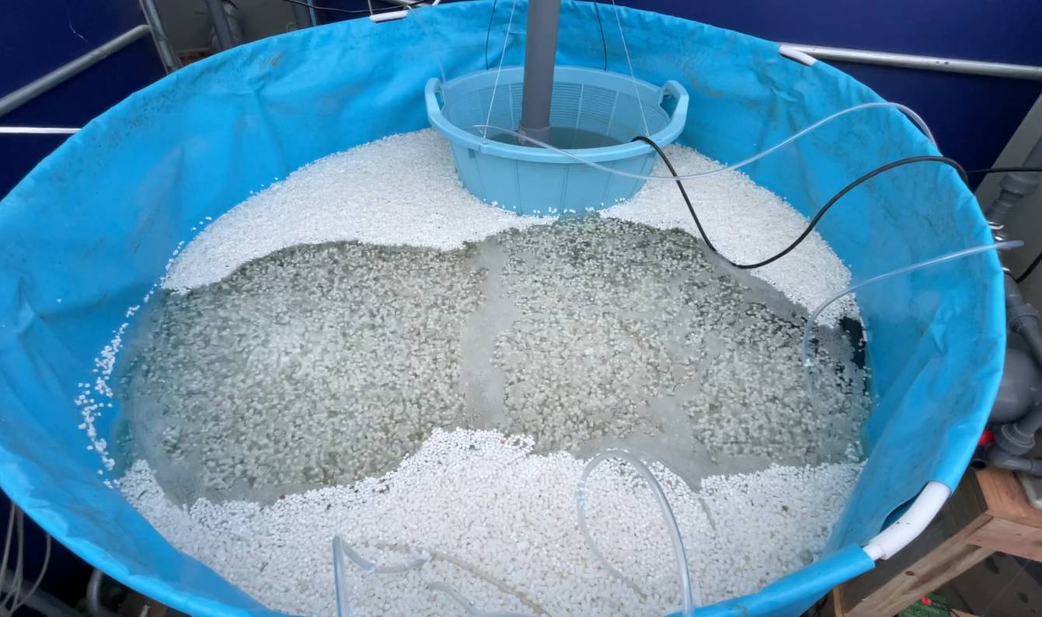

**Fig. 2 Biovector just placed, white color**

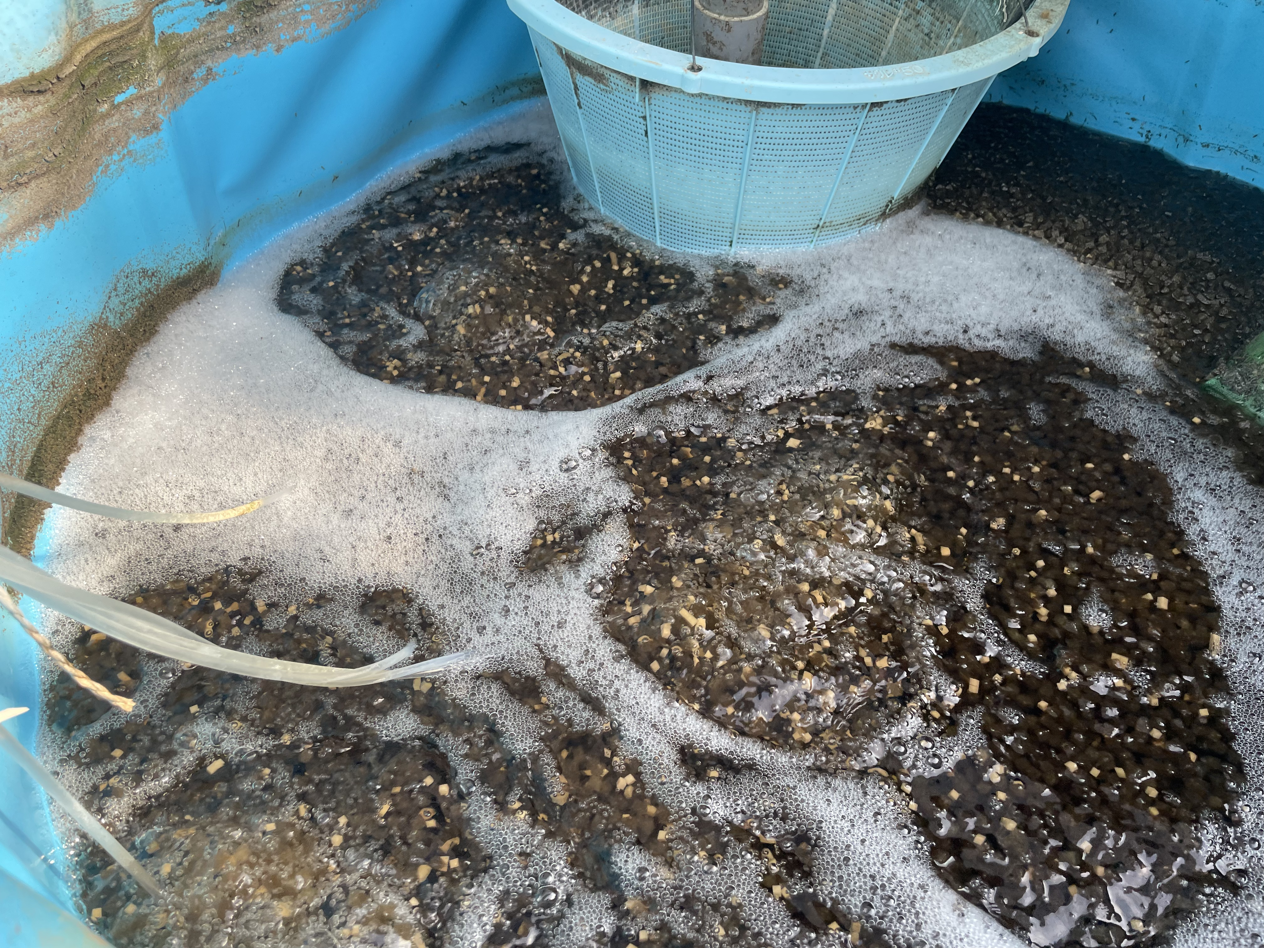

**Fig. 3 Biocarrier after three months of operation, brown color**

3.1.3 Oxygen equipment

Aquaculture in recirculating water facilities is usually conducted at medium or even high densities, and a large number of aquatic organisms require adequate oxygen supply during respiration. The current culture (July 1 to November 30, 2024) gas supply system uses several Japanese-made Yasunaga air pumps (Yasunaga エア ポンプ): voltage 100V, power ranging from 30 to 125W, air pressure ranging from 12 to 18kPa, gas flow rate ranging from 40 to 120L/min; a Chinese-made vortex air pump: voltage 200V, power of 750W (the actual measurement of 1,300W), maximum positive pressure 23kPa, maximum suction pressure -20kPa, gas flow 150 ), maximum positive pressure 23kPa, maximum suction pressure -20kPa, gas flow 150m3/h, the pump business recommended the use of water depth 1m.

During the breeding process, the vortex air pump mainly supplies air to the first, second and third pools through the centralized air supply pipeline, supplying water to the breeding area of about 37m3, and supplying a total of about 45 aeration trays. Scroll air pumps at the same time to supply one, two, three pools of biofilter aeration. In order to ensure that the biofilter aeration is complete and safe, the aeration supply in the biofilter uses the Japanese Yasunaga air pump. The turbine air pump and Yasunaga air pump work well during the whole process without any failure.

The content of dissolved oxygen in aquaculture water is related to a number of factors, mainly the number of aeration disks, aquaculture density, and the amount of respiration of aerobic microorganisms in the water.

Low Dissolved Oxygen Accident Memo:

During this culture, the dissolved oxygen in each pool was basically maintained above 4.0 mg/L. However, pools No. 1 and No. 3 had dissolved oxygen values lower than 4.0 mg/L from September 3 to September 26, and even as low as 1.0 mg/L was measured. Low dissolved oxygen occurred during the period in the continuous increase in feeding feed period, dissolved oxygen may be low due to: First, as the shrimp grows, oxygen consumption is increasing, aeration disk can not provide enough oxygen. September 10, the beginning of the two-week period, has been to increase the number of aeration disk in the pool, the dissolved oxygen values slightly rebound, but not obvious. Second, the dirt in the pool could not be discharged in time, resulting in the accumulation of solid waste in the pool, and even produced a large number of oxygen-consuming heterotrophic flocs. Particularly, adding an extra circulating water pump in pool three and using cotton cloth filtration could filter out a large amount of yellow solid pollutants. Third, dissolved oxygen and the dissolved oxygen meter in the laboratory of the University of Tsukuba were tested against each other, and no data error was found in the dissolved oxygen instrument used in the shed. But do not rule out the use of the process of measurement error. late September, one day, dissolved oxygen are suddenly recovered to 4 mg / L or more, the reason is not solved.

During the period when the dissolved oxygen value in pool 1 was lower than 4.0 mg/L, an additional pump was added to the pool to circulate and create a flow, which not only formed a vortex in the water flow, which facilitated the concentration of solid pollutants in the central drain, and allowed the oxygen-depleting substances to be discharged to the outside of the pool smoothly, but also caused an increase in the dissolved oxygen of the water body through the lifting and sprinkling of the water pump. The increase of dissolved oxygen to near-saturated dissolved oxygen in high-density aquaculture is a topic to be considered in the future.

3.2 Layout design of the breeding workshop

3.2.1 Pool Design and Distribution

The design and distribution of water pools should be rationally laid out according to the actual conditions of the site. The design and distribution of ponds in circulating water aquaculture workshop is the basis for the efficient operation of the whole system, which affects the breeding density, water quality control and the convenience of daily operation and management. In the design, the shape, size and material selection of the pools need to take into account the habits of the cultured organisms and the culture objectives. This culture uses round canvas material pools with diameters ranging from 3 to 5 meters, which are arranged and distributed in the greenhouse in a single line.

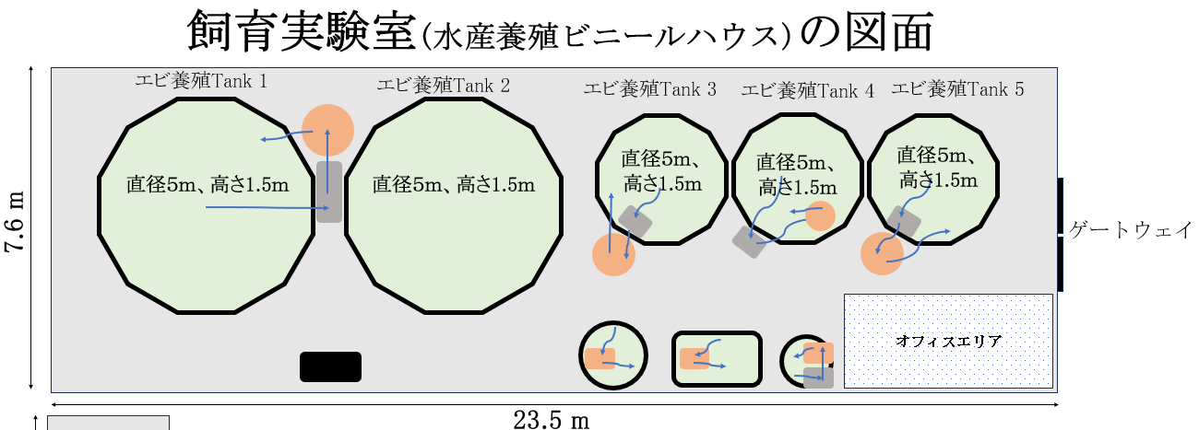

**Fig. 4 Layout plan of the farm pond**

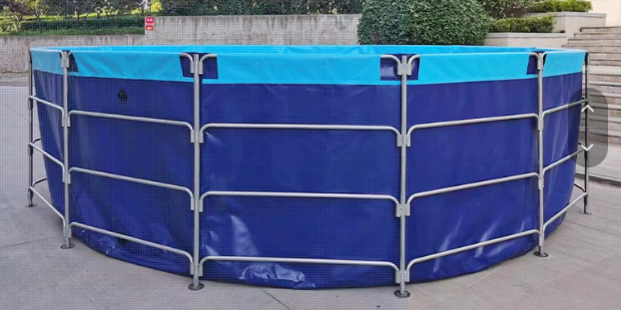

**Fig. 5 Canvas breeding tank**

The layout of the pool should be optimized according to the site conditions and process flow. Centralized layout can distribute all the pools around the central filtration equipment, shorten the length of the pipeline and improve hydraulic efficiency; while decentralized layout is more suitable for group management, especially in the phased aquaculture can be flexibly adjusted to operate. The size and number of tanks need to be reasonably planned according to the biological characteristics of specific breeding objects, breeding density and expected yield, this high-density South American white shrimp aquaculture using two 20 square meters tanks, a 7 square meters tank, the water depth of about 0.9 to 1.1 m. The tank size and number of ponds are based on the biological characteristics of specific aquaculture objects, breeding density and expected yield.

The design of the water flow is critical to the recirculation system, ensuring that the water flows evenly in the tank and that there are no dead spots. For shrimp aquaculture, a slight stirring of the water at the bottom does not affect the shrimp's life, while a central drain at the bottom helps to quickly remove solid waste. The proper distribution of auxiliary equipment such as oxygenation devices, water quality monitoring sensors and circulation lines also ensures stable water quality and system operation efficiency. In order to prevent cross contamination, water supply, drainage and circulation lines need to be designed independently and easily accessible.

Functional zoning is an important element in the distribution of pools, including seedling cultivation area, intermediate culture area and commercial culture area. This zoning design can meet the special needs of different growth stages of aquaculture objects, for example, the seedling cultivation area of smaller pools and easy to control water quality, the use of 0.4 tons to 0.7 tons of small tanks for shrimp seedling desalination and labeling coarse. It is easy to manage and use a small amount of saline water to save costs. The commercial culture area requires large tanks to accommodate high-density culture.

Backup tanks are set up to handle emergencies such as disease quarantine and system maintenance. The standby tank should be located in an area where water can be easily transferred. The volume of water in the standby tank should not be less than the volume of water in a full-fledged tank. The water in the standby tank should be prepared in advance, well aerated to provide sufficient dissolved oxygen, and left for a few days (depending on the size of the water body) so that the temperature is the same as that of the aquaculture water body. Usually groundwater dissolved oxygen between 0.5 ~ 1.0 mg / L, the temperature of about 15 degrees Celsius, are different from the conventional aquaculture water index requirements; city water supply tap water contains a certain amount of residual chlorine, is not conducive to the growth of aquatic organisms, the need for aeration a few days in advance to prepare. Spare pool salinity can be deployed as needed. Try to follow the principle of having as much as you need and being prepared.

In addition, the design of the operating aisles in the workshop should also take into account the needs of daily feeding, inspection and maintenance, and the aisles are usually set at a width of 1 to 1.5 meters to facilitate the passage of personnel and mechanical equipment.

3.2.2 Water flow design and circulation patterns

The water flow design and circulation pattern of a recirculating water culture system is a key aspect in maintaining water quality and improving culture efficiency. Proper water flow design ensures uniform water flow in the culture tanks, avoids dead ends, and allows waste, bait residues and metabolites to be efficiently concentrated and discharged. Different circulation patterns determine how the water flows through the system, including the efficiency of water purification and resource utilization.

A circulation pattern is designed using a tangential inlet and a central discharge to create a regular rotation of the water flow in the pool. This design not only concentrates waste in the bottom central discharge area for quick removal, but also mimics the natural environment's flow conditions to promote fish vitality and health. For pools with smaller diameters, such as aquaculture pools less than 3 meters in diameter, aeration can be used to enable centralized collection and discharge of dirt.

In the circulating water system, the water flow design also needs to be combined with the arrangement of equipment. For example, the oxygenation device should be placed in the intersection of water flow to enhance the distribution of dissolved oxygen; filtration system inlet and outlet design needs to avoid the short-circuit effect, to ensure that the water body full contact with the purification device. In addition, the choice and arrangement of circulation pumps directly determines the stability of the water flow and energy consumption, should be based on the size of the system and the water flow needs to match the appropriate specifications of the equipment.

The design solution of centralized sewage disposal has the potential to continue to be optimized and improved. Try to avoid powdering and decomposition of shrimp manure in the culture tank. Collecting and discharging intact large solid particles of waste out of the culture tank at the first time and quickly is a major measure to reduce pollution in the tank. Once the larger solid particles are broken down by aeration, water flow, and pump circulation into small particles of pollutants with a diameter of less than 70 microns, the pollutants cannot be physically separated even with a 200-mesh screen, which may result in gradual contamination and turbidity of the pond water.

3.2.3 Sewage Discharge and Recycling Systems

Recirculating aquaculture systems use continuously treated water for aquaculture and are essentially non-drainage, but do periodically discharge some amount of effluent containing high concentrations of solid waste (shrimp feces, erbium residue, etc.). This effluent is generally filtered out through physical filters, or through devices such as filter cloths.

Depending on the actual culture load of the tanks and the frequency of backwashing of the physical filters, a quantitative amount of wastewater with a high concentration of solids and organics is usually discharged in a few minutes to a few hours. This wastewater can be temporarily collected in containers that can hold the solid-liquid mixture for daily observation of whether these filtration devices are in good working order, and can also be used to observe whether large quantities of shrimp feces and erbium residues are being discharged, which can be used to judge the feeding of feeds in the pools and the feeding and defecation of shrimps.

In this experiment, in a 20-ton high-density aquaculture system fed about 3-5 kg of feed per day, the physical filter was backwashed for about 10 s at 15-min intervals, and about 100-200 liters of concentrated fouling wastewater was discharged.

3.3 Other Facility Configurations

3.3.1 Light system

Reasonable light design is particularly important for shrimp farming. Most shrimps, such as the South American white shrimp, are light-sensitive species that prefer low light or weak intermittent light environments during growth and feeding. Strong light may trigger a stress response, resulting in stunted growth or decreased immunity. Therefore, it is advisable to keep the light intensity in the culture workshop at about 100 to 200 lux, which can be adjusted according to the needs of shrimp fry and adult shrimp. For example, a lower light intensity is needed at the fry stage, while at the adult shrimp stage the light can be increased to promote activity and feeding.

According to the life habits of South American white shrimp, shrimp culture does not require special light design. All natural photoperiod is used in this culture. In the hot summer (June to October), black shade cloth can be added to the upper part of the light-transmitting canopy according to the situation to reduce the strong light leading to algae growth and high temperature in the pool. During the season of reduced light, the shading facilities can be removed, which is conducive to increasing the water temperature in the pool. According to the local climate data of the farm, the daily light hours in Tsukuba City, Ibaraki Prefecture, ranged between 9 hours and 42 minutes (December 21st) and 14 hours and 38 minutes (June 21st).

If required, the arrangement of the light system needs to take into account the distribution of the pool and the depth of the water body. Generally, evenly distributed flexible luminaires, such as LED or fluorescent lamps, are used to avoid strong shadows or excessive localized light intensity. Luminaires should be suspended 1 to 2 meters above the pool to ensure that the light evenly covers the entire surface of the pool while reducing the scattering and absorption of light by the water body. In addition, the use of waterproof and corrosion-resistant fixtures can extend the life of the equipment.

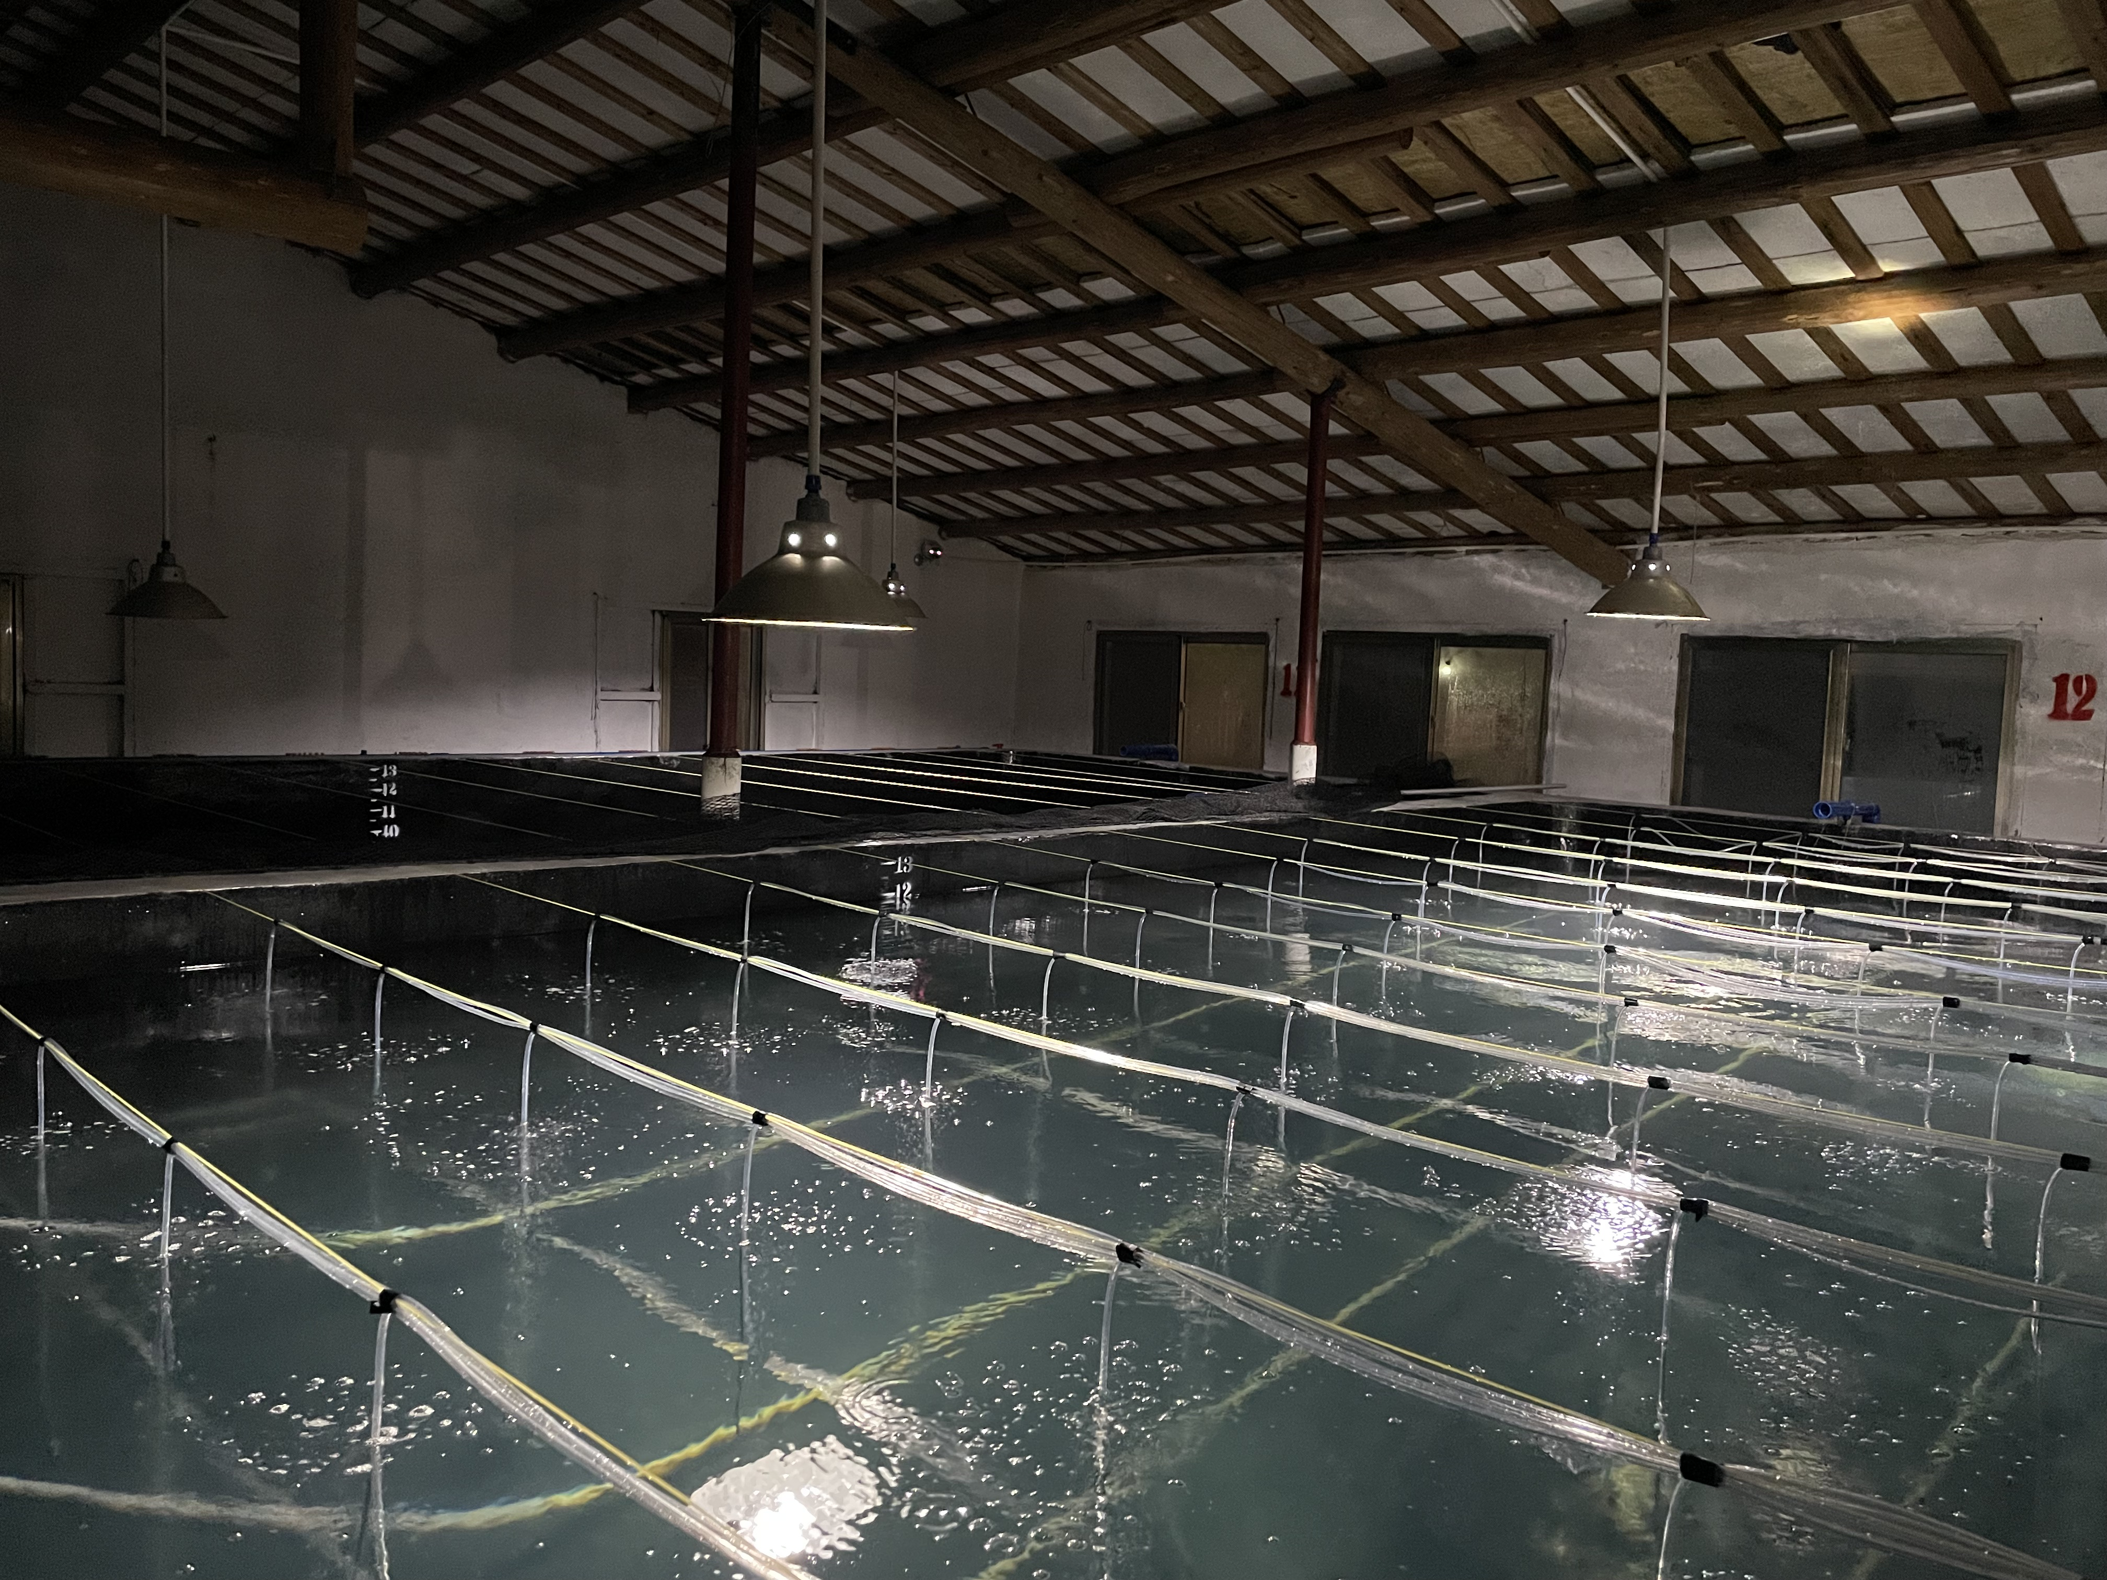

**Figure 6 Shrimp hatchery, LED lamps (for work lighting), Hainan Dingda farm, shrimp hatchery**

In terms of light time control, it is recommended to mimic the natural circadian rhythm by maintaining a cycle of 12 hours of light and 12 hours of darkness. This photoperiod not only facilitates normal shrimp growth, but also reduces overstimulation of algae and microorganisms in the workshop. If special management is required (e.g. to promote certain stages of growth or to increase spawning rates), precise control of light intensity and duration can be achieved using timers and dimmable devices.

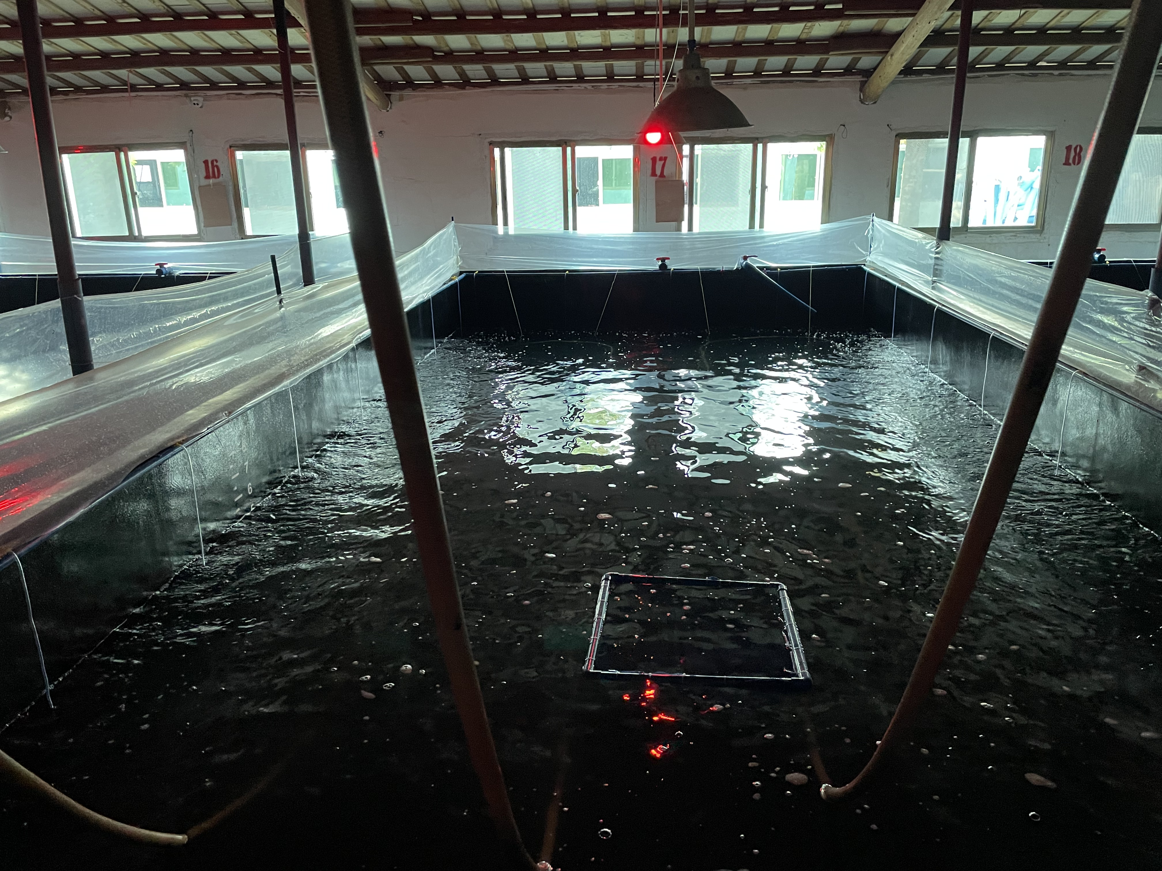

**Figure 7 Red light for mating shrimp in the mating pool, Dingda farm, Hainan, China.**

3.3.2 Ventilation systems

Ventilation setup in recirculating aquaculture system facilities is a key component to ensure air quality, maintain stable water quality and provide a healthy growing environment for aquaculture organisms. Proper ventilation design helps to remove moisture, reduce carbon dioxide (CO₂) concentration, avoid the accumulation of harmful gases such as ammonia (NH₃) and hydrogen sulfide (H₂S), and at the same time regulate the indoor temperature and humidity to prevent the growth of mold and improve the working environment.

According to the temperature in the shed and the day light conditions, appropriate adjustment of the ventilation of the shed to avoid the temperature is too high or too low, conducive to maintaining the water temperature of the breeding pool in the 26 ~ 30 degrees Celsius. It is also suitable for staff to work in the shed.

3.3.3 Backup power systems

The normal operation of all the equipment in the aquaculture system requires stable and continuous power; once the aeration device is disconnected, it will lead to a short-term drop in dissolved oxygen in the aquaculture tank, resulting in shrimp asphyxiation and death.

The backup power system is composed of a lithium battery and an automatic power switch that changes power from the city power supply to the lithium battery when the city power supply is interrupted, with a switching time of less than 1 second. Important electrical equipment is generally connected to the backup power supply, mainly equipment such as blowers that must work 24 hours a day. It is necessary to ensure that the power supply system can work unattended for more than 5 to 10 hours.

Check the remaining power of the backup power supply daily. If you need to charge the backup power supply, try to charge the backup power supply to more than 90% every day. Don't let the backup power supply less than 50%. Do not charge when people leave the shed to avoid accidents such as fire. Once a week, check whether the backup power supply system is working properly: manually cut off the city power supply, check whether the backup power supply can be automatically switched normally, and whether the blower is working properly.

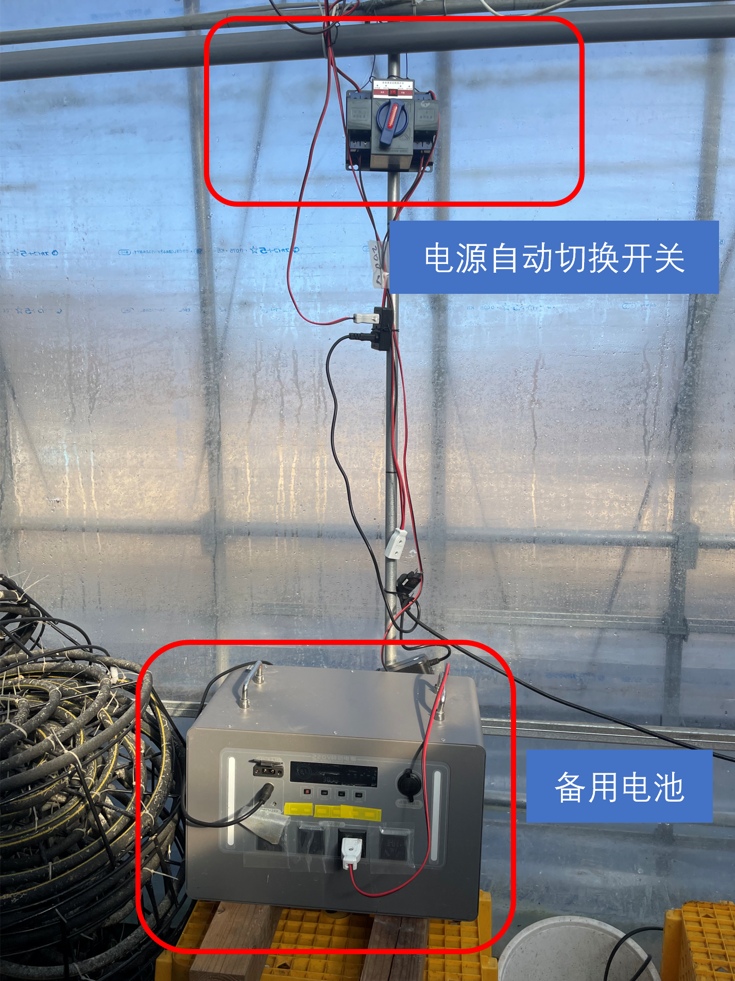

**Figure 8 Backup power system**

Chapter 4 Construction of factory circulating water systems

4.1 Pre-construction preparation

A minimum culture unit is a system containing a water circulation unit, an air supply system, a feed delivery system, test reagents, etc. that can guarantee one adult shrimp culture cycle. According to the design of a minimum unit, the list of equipment to be purchased is as follows.

|  |  |  |
| --- | --- | --- |
| **Table 3 List of equipment to be purchased for a farming system** | | |
| **serial number** | **goods** | **note** |
| 1 | breeding pool | Selected according to need, diameter about 3~7 meters |
| 2 | Physical filters | Selection according to the size of the breeding tank |
| 3 | biofilter | Generally 5-10% of the volume of culture water |
| 4 | biovector | Typically 30% of biofilter volume |
| 5 | water pump | The maximum amount of water per hour is designed according to 1~2 times of the culture water body. |
| 6 | air pump | 750 W, can supply about 30~50 square meters of farming area |
| 7 | backup power | Can supply air pump for more than 10 hours of work |
| 8 | water pipes | select on demand |
| 9 | Automatic food dispenser | 1~4 units |
| 10 | flangeless disk | Connecting physical filters and biofilters |
| 11 | fishbowl | 1 set of fish toilets+ risers |
| 12 | aeration disk | Prepared at 1.5 per square meter |
| 13 | Aeration tubes and switch parts | Prepare as needed |
| 14 | fish for a net | several |
| 15 | Reagents for water quality analysis | Rapid analytical reagent for ammonia nitrogen and nitrite nitrogen |
| 16 | pH meter | 1 unit |
| 17 | Dissolved oxygen meter | 1 unit |
| 18 | Timer switch (for water pump) | 1 unit |
| 19 | prawn feed table | 3 to 5 |
| 20 | Thickened sewage systems | 1 set (bucket, pump, etc.) |
| 21 | Automatic water level sensor switch | 2 sets |
| 22 | 100V to 220V Transformer | 1 unit |

Depending on the construction preparation, tools such as pliers, screwdrivers of various types, wrenches, ladders, gloves, etc. should also be prepared.

4.2 Installation of equipment and layout of ancillary systems during construction

The construction process can be divided into several stages such as design preparation, civil construction, equipment installation, commissioning and operation, each of which requires careful planning and efficient coordination. According to the way of water circulation of aquaculture system, first, according to the current situation of the site, planning reasonable design drawings, according to the drawings of the construction. Field survey and determine the size of the corresponding site, the current situation, make a reasonable construction plan.

The civil construction stage is an important basic link in the construction of the circulating water system, first of all, we should carry out foundation treatment of the construction site to ensure the waterproof performance of the breeding pool, and avoid the sharp objects scratching the breeding pool. Ensure that the slope of the pipeline is reasonable and tightly connected to avoid clogging or leakage problems in future operation.

Equipment installation is the key link to realize the function of the system. A variety of larger filtration equipment (such as physical filters, biofilters) need to be installed in place in accordance with the design requirements to ensure that the direction of the water in and out of the correct and reserve enough space for maintenance. The connection of pumping station and pipeline should pay special attention to the sealing and pressure resistance.

The installation of the electrical system should consider safety and ease of use. Breeding workshop is more humid, avoid the power supply line touching the wet place; avoid the electric wire, especially the socket falling into water.

4.3 Equipment commissioning and operational testing

Once the equipment is installed it needs to be commissioned and tested for operation. Once the equipment has been installed, it is necessary to wait for all the glue to dry and check that the areas to be sealed are complete.

|  |  |  |
| --- | --- | --- |
| **Table 4 System acceptance criteria** | | |
| **serial number** | **element** | **probe** |
| 1 | All tubing joints for leaks; | Visual observation; inspection using a dry rag or paper towel |
| 2 | Wire and power safety; | naked eye examination |
| 3 | Adequate aeration of the biofilter | Visual observation of production; fishing the bottom with a net for large deposits of biocarriers; dissolved oxygen meter detection |
| 4 | Adequacy of aeration in the breeding pond | Dissolved Oxygen Meter Test |
| 5 | Whether the physical filter effluent is smoothly discharged to the designated location | Manual testing of physical filter backwash function |
| 6 | long term stability | One day to stabilize |

Chapter 5 South American white shrimp daily culture management

5.1 Water Quality Monitoring and Maintenance

5.1.1 Control of pH, salinity, temperature, dissolved oxygen

pH is tested by a simple pH meter, calibrate the pH meter frequently. Water temperature can be measured by aquaculture-specific electronic thermometers or traditional glass thermometers. Electronic thermometers are easy to read and can be monitored quickly and intuitively, but due to the high temperature and humidity of the greenhouse, electronic thermometers are easily damaged. Dissolved oxygen is tested by dissolved oxygen instruments. Dissolved oxygen instruments are more sophisticated and require dedicated maintenance. All electronic testing equipment needs to be placed in a ventilated and cool place, avoiding direct sunlight and water spills.

It is recommended to test the pH of aquaculture water on a daily basis. pH is very useful for observing the changes in water quality and adjusting the condition of aquaculture water in time. pH decrease is generally caused by the nitrification reaction which consumes a certain amount of alkalinity. When the nitrification reaction is strong, even daily pH decreases regularly. When the pH is lower than the optimal range (7.6~8.4), it is necessary to add 10% lime milk to adjust. The specific operation is as follows:

1. In general, if the pH is below 7.6, adjust it according to the standard of adding 25 to 50 ml of milk of lime per cubic meter of water.
2. If the pH is between 7.6 and 8.0, but pH monitoring reveals a downward trend in the daily pH, milk of lime can be added appropriately to avoid the pH dropping below 7.6;
3. Lime milk should be added according to the actual situation, the right amount, multiple times to avoid drastic fluctuations in the pH of the water body.
4. According to this aquaculture experience, aquaculture pools put (every 20 tons plus about 1 ~ 2 liters of 10% milk of lime when) milk of lime, will lead to a short period of time a sharp rise in pH, half a day~ a day time to return to the original value, this may be the shrimp growth pressure; it is recommended that you can be a small amount of more than a few times the milk of lime, for example, you can use peristaltic pumps, such as the daily timing and quantitative injection of milk of lime.

Salinity is very important to the growth of South American white shrimp, in general, South American white shrimp do not need salinity adjustment in the aquaculture process, except for desalination culture in the seedling stage, or desalination culture of prawns re-salination back to normal seawater salinity. According to the literature, the minimum salinity that can be tolerated by desalination culture of South American white shrimp is 2 parts per thousand (it is recommended not to go below 3 parts per thousand). However, it should be noted that the physical filter drainage will discharge a portion of the salt, according to the frequency of physical filter drainage, the salinity of aquaculture water can be monitored, and it is necessary to replenish the sea salt corresponding to the discharged salt every week to maintain the salinity at a stable level. It should also be noted that the culture water body will evaporate during the culture process, the water body temperature, the culture water body area leads to evaporation of fast and slow. Generally speaking, according to the fixed aquaculture water level (e.g. 1.0 meter), 2~3 days need to replenish the appropriate amount of evaporated fresh water to the original water level.

The nursery process is seawater, and when desalination is required, the process of desalinating the water body in which the seedlings are raised to a level suitable for freshwater (salinity of about 3) culture is called desalination. Precautions for desalination are as follows: ①Desalination is usually carried out in a small body of water to facilitate the operation of drainage and water exchange. During the seedling stage (about P5~P20), the density can be about 10,000 tails per square meter; ② daily water change operation, it is recommended that the daily desalination salinity is not higher than 3, which is conducive to the maintenance of the stability of the seedlings; (although it is possible to desalinate more than 5 salinity per day, but it is not recommended.) ③ daily through the discharge of a certain amount of seawater, into a certain amount of fresh water for desalination, into the fresh water must be similar to the indicators of the culture water, pH does not differ by more than 0.5, the temperature does not differ by more than 0.3 degrees Celsius.

Nitrifying bacteria will be weakened by adaptation to the changing salinity during desalination, so it is necessary to domesticate the nitrifying bacteria in the biofilter in advance. It is necessary to domesticate the nitrifying bacteria in the biofilter 10 days in advance so that the biofilter is in a salinity 30 working environment. (Patent pending.)

Below is a standard desalination process for a 1 ton body of water.

|  |  |  |  |
| --- | --- | --- | --- |
| **Table 5 Desalination process (1 ton of water)** | | | |
| **Number of days of desalination** | **Salinity, parts per thousand** | **water exchange rate** | **water exchange ratio** |
| Day 1 | 35 | 85 liters | 8.% |
| Day 2 | 32 | 94 liters | 9% |
| Day 3 | 29 | 103 liters | 10% |
| Day 4 | 26 | 115 liters | 11% |
| Day 5 | 23 | 130 liters | 13% |
| Day 6 | 20 | 150 liters | 15% |
| Day 7 | 17 | 177 liters | 18% |
| Day 8 | 14 | 214 liters | 21% |
| Day 9 | 11 | 272 liters | 27% |
| Day 10 | 8 | 375 liters | 38% |
| May be placed in culture ponds; salinity of the ponds is 3%. | 5 | Adjusted to similar salinity as the pond | suitability |

Salinization is the process of salinization of desalinated farmed adult shrimp, with sea salt, to seawater salinity. The salinization process was carried out twice during this culture. The salinization process is a gradual increase in sea salt, compared with the desalination process operation is simple, and the osmotic pressure increase is to restore the native environment, less risky. The main function is to restore the desalinated adult shrimp to the state of mariculture, which facilitates mating and reproduction for spawning. It can also be considered in the late stage of culture, the desalination of adult shrimp culture, through a short period of salinization culture, to play the role of increasing the taste of food, reduce parasites. (Patent pending.)

Temperature is recommended to be tested daily. Temperature variations can affect the feeding activity and vigor of shrimps. The general optimum temperature is 28 to 32 degrees Celsius. In summer greenhouses, the water temperature can usually be maintained at around 30 degrees Celsius for feeding, which is ideal for shrimp growth. In the Kanto region, the temperature starts to drop from November until the water temperature is around 20 degrees Celsius, when the shrimp have reduced their feeding, and temperatures below 20 degrees Celsius kill about 5~10% of shrimp per day.

Dissolved oxygen needs to be guaranteed to be at least 4.0 mg/L, with 5.0 to 8.0 mg/L being optimal. Dissolved oxygen is the most rapidly responded to indicator of shrimp survival, which means that if dissolved oxygen falls below the lower limit (usually 1.0 mg/L) for an hour or even minutes, it can result in shrimp asphyxiation. Dissolved oxygen is monitored using a dissolved oxygen meter, which is relatively easy to use. However, it is necessary to consider how to increase the dissolved oxygen when it decreases, especially in the case of sufficient aeration. During this culture, the DO was monitored to a very low value (less than 2.0 mg/L), which is generally considered to cause shrimp death. This was resolved by replacing the use of a large aerator and increasing the number of aeration trays. If there is a continuous decrease in dissolved oxygen during the culture process, or the measured value is abnormal, it is necessary to repeat the measurement at different points, using different dissolved oxygen meters, to ensure that the test value is accurate. The normal low dissolved oxygen in daily aquaculture may be caused by the high density of aquaculture, the oxygen-consuming microorganisms reproduction in the water body is too strong, which can be solved by increasing the aeration disk, increasing the efficiency of dissolved oxygen, such as the use of new aeration disk or the use of micro-nanometer bubble technology or even pure oxygen aeration.

Under factory farming conditions, dissolved oxygen is recognized as an indicator that needs to be monitored without interruption. From the existing public information of large-scale factory farming, it is seen that temperature, dissolved oxygen, and even pH and salinity are monitored online in real time. Of course, considering the balance of cost and benefit, there is little real-time monitoring of dissolved oxygen in traditional small shed culture, high pond culture, and even some factory farming. Generally accidental DO reduction is due to the interruption of air supply facilities resulting in the loss of aeration function of all culture aeration disks. Simple aeration interruption warning device, automatic switching device of backup power supply and online network monitoring camera equipment can be used.

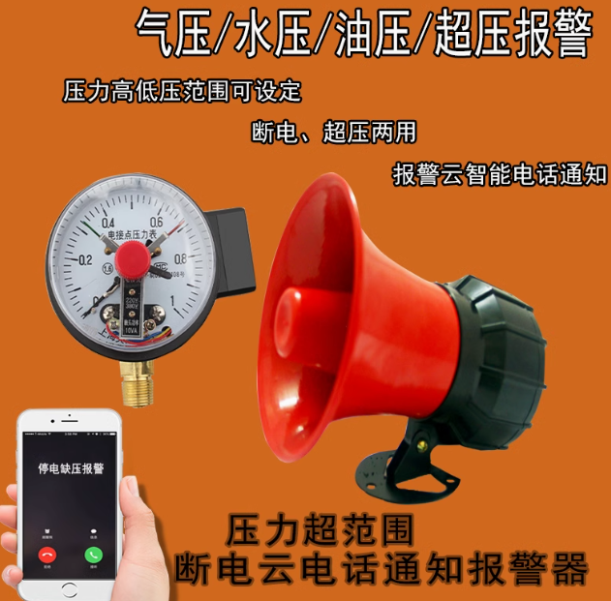

**Fig. 9 Oxygen cut-off alarm for power outage and gas outage Aquaculture Oxygen deficiency alarm**

5.1.2 Frequency of water quality testing and data recording

Water quality testing focuses on ammonia and nitrite, with nitrate less than 200 mg/L generally considered harmless to shrimp. Ammonia is monitored using a simple kit and should generally be less than 0.1 mg/L, which is easy to achieve under the right conditions of bioreactor domestication. Nitrite is monitored using simple kits and should generally be less than 0.5 mg/L. Based on the literature and experience, nitrite oxidizing bacteria (NOB) require a longer period of domestication to immobilize on the biocarrier than ammonia oxidizing bacteria (AOB). All data should be recorded clearly according to time, water temperature, pH, ammonia nitrogen, nitrite nitrogen, nitrate nitrogen, dissolved oxygen, salinity, feeding rate, and remarks. Data should be clear, data units should be complete, and daily operations and remarks should be recorded.

Sudden changes in water quality can be caused by overfeeding, equipment failure or environmental changes. The cause of water quality deterioration needs to be found quickly and accurately. Check mainly for the following problems:

1. If the physical filter is clogged resulting in poor water circulation, the solution: thoroughly clean the physical filter, unclogging the water circulation; check the water circulation pump, etc..
2. If the dissolved oxygen in the biofilter is less than 4.0 mg/L, solution: increase the biofilter aeration head.
3. If overfeeding, there is leftover feed on the feed table, solution: reduce the amount of feed on the day~ second day and wait for the water quality indicators to return to normal.
4. If the water environment changes due to environmental changes, such as a sharp drop in temperature, etc., effective measures should be taken in a timely manner, such as timely opening and closing of the greenhouse insulation to maintain the appropriate breeding temperature.
5. A large number of dead shrimp due to deterioration of water quality, timely fishing out dead shrimp to avoid further deterioration of water quality.

5.2 Feeding management

5.2.1 Feed types and ratios

The type and proportion of feed is one of the key factors in feeding management. Different growth stages of South American white shrimp require different types of feed. For example, the larval stage is suitable for pellet or powder feed with high protein content, while in the growth stage can choose puffed feed with medium protein content and moderate supplementation of animal protein. Near the shrimp stage, the fat content in the feed can be increased to enhance resilience. At the same time, the nutrients in the feed need to be reasonably proportioned, such as the proportion of protein, fat and carbohydrates should be in line with the nutritional requirements of shrimp, and appropriate additions of micronutrients and probiotics to enhance growth and disease resistance. During this culture period, during the seedling period (0~10 days) (estimated to arrive at the greenhouse of the seedling period is about Z15) use the Shoda baby shrimp production powdered feed, the middle and late stage (11~ 90 days) use the Shoda Spotted Prawn Zero Crusher (label: 45 protein 9980) and the Japanese Higashimaru (Higashimaru) South American White Shrimp adult shrimp feed.

Three sizes of feeds were used in this culture, mainly powdered feeds, zero crushed feeds and number one feeds. The feed sizes and daily feeding ratios used in different farming periods are shown below.

|  |  |  |
| --- | --- | --- |
| **Table 6 Feed specifications used in different farming periods, in the case of CZ feed (CP)** | | |
| **shrimp period** | **Feed specifications** | **Daily feeding as a percentage of body weight** |
| 0 to 10 days, seedling stage (P15 to P25) | powder | 20% |
| 11~ 40 days, transition period | Mixing of powdered and zero-gauge materials | 12% |
| 31 to 40 days, seedlings | material not intended be used | 9% |
| 41 to 60 days, medium seedlings | Mixing of Material Zero and Material One | 6% |
| 61 to 90 days, adult shrimp | No. 1 material | 4% |

5.2.2 Time and method of feed feeding

The time and method of feeding should be scientific and reasonable. It is usually recommended to feed four times a day, respectively at 4:00 am, 10:00 am, 4:00 pm and 10:00 pm at night. Feeding should be done in small quantities to avoid feed waste and water pollution. Can be combined with automatic feeding equipment and manual observation to ensure that the shrimp ingestion is uniform. For the control of the feeding amount, should be adjusted dynamically according to the shrimp size, density and water temperature and other conditions, the general daily feeding amount of 5% -10% of the weight of the shrimp. Through the "tray check method" to observe the shrimp's feeding, if there is leftover material, you need to reduce the amount of feeding. About 70 minutes after feeding to check the material table, such as the material table has leftover material, that is, overfeeding, need to reduce the amount of feeding; if the feed is basically no, but there are still shrimp, that is, not enough feeding, need to appropriately increase the amount of feeding. Pay attention to changes in water quality, if the water quality deteriorates, especially ammonia nitrogen and nitrite concentration increases, usually indicates that the feeding amount is too large, the feed is not fully consumed, need to reduce feeding.

You can save on labor by using an automatic feeding machine. There are various options for automatic food feeding machines, choose the one that is easy to use and easy to maintain. Can be selected according to the need for network online version. In general, according to the different stages of South American white shrimp feeding feed particle size to change the automatic feeding machine single feeding bayonet size, according to the different stages to change the setting of the amount of food. Specific methods of use refer to the purchase of feeding machine business website, and business customer service communication.

The amount of residual feed in the automatic feeder needs to be checked daily for adequacy. In the later stage of breeding, a 10-liter capacity automatic feeder can feed up to 2~3 kg of feed per day, which needs to be added every 2~3 days without forgetting. You can check whether the feeder is feeding properly at the right time.

The arrangement of the feeding machine and feeding sprinkling needs to be reasonable. The general diameter of 5 meters of the breeding pool needs to be arranged three small automatic feeding machine, and the addition of automatic sprinkling equipment, can make the feed evenly sprinkled to the whole pool, conducive to shrimp ingestion. Automatic feeding machine feed outlet easily clogged and dirty, need to be cleaned in time.

The management of culture density has an important impact on the growth rate and health of South American white shrimp. In high-density culture, shrimp growth is easily inhibited, so it is necessary to rationally design the culture pool, and the general initial seedling release density is 500~1000 tails/m². As shrimp weight increases, the density should be gradually reduced. In addition, regular stock splitting and density adjustment are important operation methods, every 2-3 weeks through the mesh sieve to separate the growth of individuals with different growth speeds, which can help to reduce the competition between individuals, reduce the stress response, and thus improve the overall yield.

However, in the early stage of breeding, when using powdered feed, it is not suitable to use automatic feeding machine and adopt manual feeding. Powdered feed needs to be mixed with a certain amount of water, so that the powdered feed is fully dissolved in a certain amount of water, the

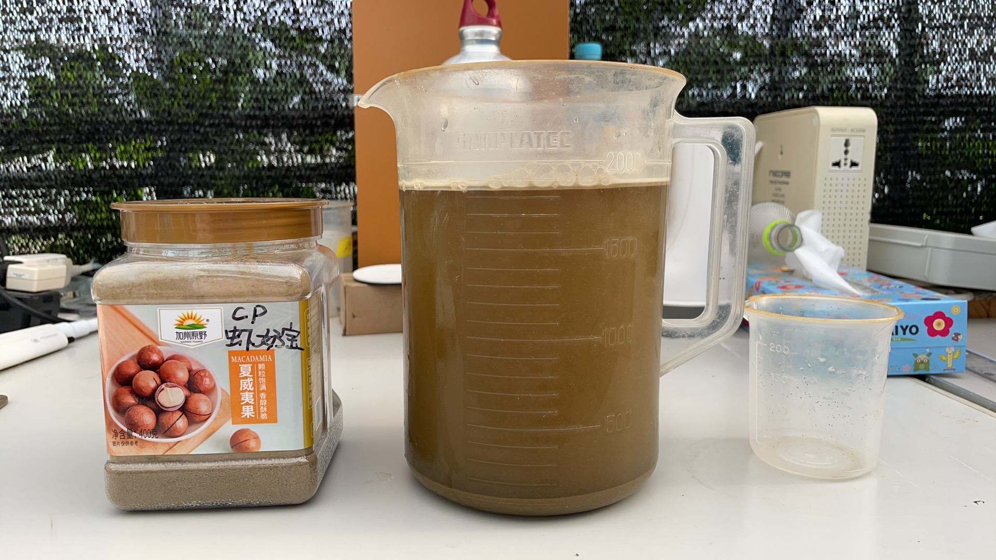

**Fig. 10 Powdered feed (Zhengda - shrimp milk treasure) dissolved in water and then feeding**

Then evenly splash the amount into the seedling culture pool. Do this 2 to 3 times a day and try to do it 4 times a day if possible. If the powdered feed is also on the large side during the earlier nursery period and you need to use smaller particles, you can pour the powdered feed into a 200 mesh strainer and step by step knead the feed into a certain amount of water by hand, so that the small particles of feed are fully suspended in the water, and then evenly splash it into the small fry breeding pool.

5.3 Disease Prevention and Management

Disease prevention and management is an important part of aquaculture management. Common South American white shrimp diseases include white spot syndrome (WSSV) and Vibrio infections. To prevent these diseases, water quality management and biosecurity measures should be strengthened, such as keeping the dissolved oxygen in the water higher than 5 mg/L and ammonia nitrogen lower than 0.1 mg/L, and disinfecting the water regularly to avoid introducing pathogens. At the same time, probiotics or immune enhancers can be added to the feed to enhance the shrimp's disease resistance. In the event of a disease outbreak, sick shrimp should be isolated immediately to minimize cross-infection, and targeted treatment measures should be taken after detecting the cause of the disease (viral, bacterial, or environmental), such as stopping feeding, appropriate water changes, and improving water quality. The use of drugs must be standardized, strictly select the nationally permitted aquatic drugs, prohibit the abuse of antibiotics, and record the name of the drug, dosage, date of use and reasons. In addition, it should be ensured that the drug withdrawal period has expired before harvesting to avoid the impact of drug residues on product quality.

Through scientific feeding management, density adjustment and disease prevention measures, the culture efficiency and yield of South American white shrimp can be significantly improved, while ensuring the health of the shrimp population and product safety.

Chapter 6 Routine equipment maintenance

6.1 Cleaning and replacement of filtration equipment

The filtration equipment in this system is primarily a backwashing microfilter. The frequency of backwashing of the microfilter is determined by the amount of solid contaminants in the tank, usually about 10 to 20 seconds for 30 to 120 minutes, with automatic backwashing used when needed. The flushed solids are disposed of as waste, and the amount of contaminants flushed out needs to be checked on a daily basis and used to determine if the backwash microfilter is working properly to remove enough solids from the tank. If the discharged backwash liquid contains most of the water, and less solid pollutants, indicating that the filtration effect of the backwash microfilter does not reach the ideal condition, combined with the pollution in the breeding pool, need to make further judgments; if there is no sufficient amount of concentrated backwash liquid, proving that yesterday's backwash microfilter is not normal backwash, you need to check the backwash pumps, backwash piping and so on, whether it is normal, smooth and working. smooth. Backwash microfilter is an important solids filtration and discharge equipment, need to check whether the work is good every day. Once there is an abnormality, you need to promptly remove the abnormal condition.

While backwashing microfilters can work automatically, daily checks for daily maintenance are necessary. The interior of the microfilter needs to be cleaned weekly using a high pressure water gun or pump working in conjunction. Areas that need to be thoroughly cleaned include, but are not limited to, the microfilter screen, the backwash nozzle, the backwash V-tank, the water inlet bin, and the water filtration bin. Every two weeks you need to check whether the backwash pump is working properly, you need to check the backwash pipe, if it is clogged, you need to dismantle it, clean it, and maintain it to ensure that the backwash microfilter is working properly.

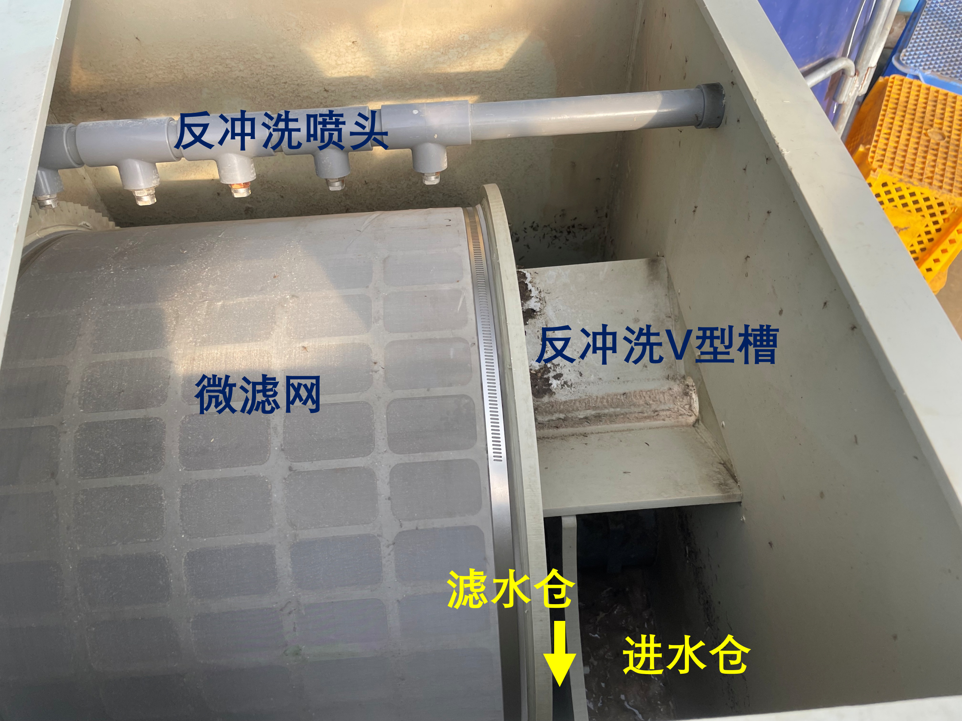

**Figure 11 Backwashing Microfilter Internal Cleaning and Maintenance**

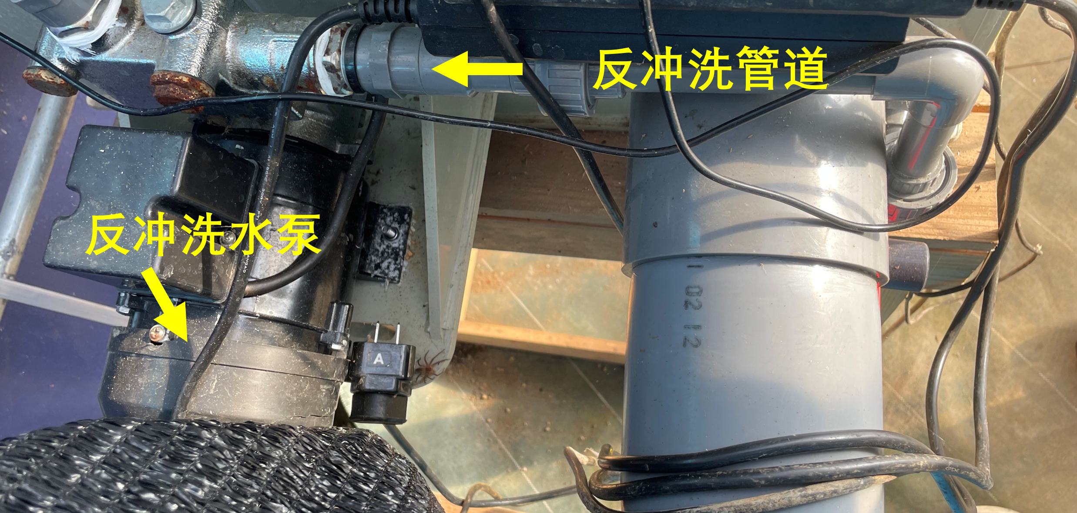

**Figure 12 Backwash Microfilter External Cleaning and Maintenance**

The parts and intervals of the microfilter that require maintenance are listed below.

|  |  |  |
| --- | --- | --- |
| **Table 7 Components and intervals of microfilter requiring maintenance** | | |
| **place** | **Cleaning content** | **Cleaning cycle** |
| microfilter | High-pressure water gun rinsing to avoid biofilm clogging (to avoid damage to the filter under too much pressure) | Checked daily; cleaned once every few days |
| Backwash nozzles | Just check. | Daily checks |
| Backwash V-tank | High-pressure water gun flushing | Checked daily; cleaned once every few days |
| watering can | High-pressure water gun rinsing to avoid excessive deposits | Checked daily; cleaned once every few days |
| water filtering bin | High-pressure water gun rinsing to avoid excessive deposits | Checked daily; cleaned once every few days |
| Backwash pumps | probe | Checked daily, no damage requires no maintenance |
| Backwash Pipes | Check; avoid clogging pipes with excessive internal biofilm. | Checked daily, no damage requires no maintenance |

6.2 Maintenance and management of biofilters

Biofilter is an important equipment to ensure that the biochemical reaction is carried out normally and harmful pollutants such as ammonia, nitrite and so on are converted into nitrate. Ensure that the biofilter's reasonable water circulation will adequately treat the water from the aquaculture tank and return it to the aquaculture tank. Biofilter is the core equipment and needs to be checked daily.

In this case, the main maintenance point was found to be the poor water circulation. When the pump cycle stops, or backwash microfilter clogging leads to insufficient water into the biofilter will lead to breeding pond water can not enter the biofilter to be treated. At this time, the water circulation problem should be solved in time, so that the biofilter can play a role in treatment.

Secondly, it is necessary to fully ensure that the dissolved oxygen level everywhere in the tank is above 4.0 mg/L. Especially for the bottom portion of the bio-carriers, from time to time, because the arrangement of the aeration stones/aeration tubes is not reasonable enough, or the aeration stones/aeration tubes move over time, the aeration position in the biofilter is not uniform, and a portion of the bio-carriers are piled up in the corners. Moreover, if the aeration volume is not large enough, or the placement of aeration stones/aeration tubes is not large enough, there is a considerable amount of biocarriers piled up at the bottom, which is substandard. Try to use sufficient air volume for aeration and secure the aeration device trap bundle in a fixed position.

Biofilters need to be maintained and inspected as follows.

|  |  |  |
| --- | --- | --- |
| **Table 8 Biofilters requiring maintenance and inspection** | | |
| **place** | **Inspection and maintenance contents** | **cyclicality** |
| biovector | Whether it is fully stirred and whether there are any dead areas | everyday |
| dissolved oxygen | Dissolved oxygen greater than 4.0 mg/L | everyday |

6.3 Inspection of piping, aeration and other equipment

Daily inspections of sheds include all matters related to the presence of water leaks, constant air supply, electricity and equipment. It is necessary to scrutinize each item and even anticipate the risks that may occur and remove them in time.

All checks are made once a day when entering the shed to deal with problems promptly; and once when leaving the shed. All operations are done in a timely manner, so that no problems are left behind. Remember Murphy's Law, which means that where there is a possibility of a problem, there will be a problem, but it is only a matter of time. What you need to do is to eliminate possible problems at the early stage, avoid problems that may occur, and improve the overall design, management and operational efficiency.

|  |  |  |
| --- | --- | --- |
| **Table 9 Daily inspections** | | |
| **entry** | **element** | **Inspection frequency** |
| **greenhouse as a whole** | * No abnormalities in film integrity * No abnormality in opening and closing ventilation on both sides * The door locks are working. | eeveryday |
| * **water**   No unusual water damage on the ground; no unusual water levels in the closed pools | | |
| breeding pool | Whether water leakage, focusing on the pipe joints, without the risk of being scratched by foreign objects | everyday |
| Water circulation pipes | Whether water leakage, focusing on the switch, pipe joints, no abnormal stress points | everyday |
| water pipes | * Is the switch properly seated * Are the pipes intact and not leaking | everyday |
| * **Aeration**   Listen to the sound of aeration; see the normal aeration of each aeration point | | |
| aerator | Listen to the sound of the scroll aerator can determine whether the normal work; touch the aerator whether the normal vibration, whether overheating | everyday |
| aeration pipe | Whether there is an abnormal sound of air leakage; whether it is detached | everyday |
| Aeration stone/aeration disk | Whether or not there are bubbles of the right size coming out | everyday |
| * **electronic**   Check that the equipment is illuminated and in normal operation | | |
| cords | Don't risk water ingress | everyday |
| sockets | Don't risk water ingress | everyday |
| backup power | * Don't risk water ingress * Charging is required when the power level is below 50%; charging is prohibited in the absence of personnel | everyday |
| Automatic diverter switch | Test it once to see if it's working properly | Once per week |
| * **installations**   Normal operation of equipment | | |
| microfilter | Tests that the backwash is working properly | according demand |
| Automatic food dispenser | * Can be tested for normal feeding * Check that the amount of leftover food is sufficient | according demand |

6.4 Periodic cleaning and sterilization of the system

The overall system is initially clean and free of exogenous pathogenic microorganisms, but in order to prevent epidemics, it is necessary to disinfect the water and the entire system, tools, etc. at the beginning of the culture. Usually hypochlorite, potassium permanganate or iodine compounds (e.g. povidone-iodine) are used. In this case, industrial bleaching powder (calcium hypochlorite) with 70% effective chlorine and 50 grams per cubic meter of water body was used for disinfection before entering the seedlings.

Hypochlorite (e.g., sodium hypochlorite, bleach) is a highly effective oxidizing disinfectant that is widely used to disinfect water bodies, facilities, and fish eggs in aquaculture. Its common concentration is 1～ 5 mg/L (effective chlorine concentration) for water disinfection and 200～ 500 mg/L for disinfection of tools and facilities. To use, hypochlorite needs to be dissolved and diluted and then evenly splashed or soaked. Hypochlorite is suitable for killing bacteria, viruses and some parasites in the water body, but care should be taken to avoid overdose to prevent stress to aquaculture organisms or side effects to the environment, such as the generation of chlorination by-products. In addition, its active ingredients are easily affected by sunlight and temperature, so it should be used now.

Potassium permanganate is a common oxidizing disinfectant mainly used for water disinfection, parasite control and water quality improvement. The usual concentration is 0.5～ 1 mg/L for water disinfection, which can be increased to 2～ 4 mg/L for whole-pool splashing to control parasites; for fish and shrimp immersion treatment, 10～ 20 mg/L is used with a soaking time of 15～ 30 minutes, while the concentration for tool disinfection is 100～ 200 mg/L with a soaking time of about 30 minutes. Potassium permanganate should be used by uniform splashing or soaking after dissolution, and is suitable for treating in vitro parasites of fish and shrimp, water mold and other problems, as well as oxidizing organic matter in the water column. However, its effect will be weakened in environments with poor water quality and more organic matter, and may accumulate manganese dioxide (MnO₂) in the substrate, requiring timely water changes. Sensitive organisms such as shrimps need to use high concentration with caution to avoid toxicity.

Povidone iodine is a highly effective and low toxicity iodine preparation, which is widely used in aquaculture for water disinfection, disease prevention of fish eggs and parents, and wound treatment. For water disinfection, its effective iodine concentration is 1～ 2 mg/L, while for fish eggs and parental fish disinfection, it is used to soak 10～ for 15 minutes with 10～ 20 mg/L, and for wound treatment, it is used to make coated with 50～ 100 mg/L or soaked for a short time. Povidone iodine is highly stable in water and has good killing effect on bacteria, viruses and fungi, especially suitable for sensitive fish and shrimp eggs and local treatment of infected wounds. It is necessary to control the dosage to avoid toxicity caused by too high concentration, and pay attention to the storage expiration date of the agent and the interaction with other drugs.

Reasonable selection and use of disinfectants such as hypochlorite, potassium permanganate and povidone iodine can effectively control pathogenic microorganisms in the water body, improve the aquaculture environment, and prevent diseases, but it is necessary to combine with the actual aquaculture conditions and the resistance of the organisms to control the dosage and frequency strictly, to avoid the side effects and reduce the impact on the environment.

After conducting a culture cycle, it is also necessary to disinfect the culture system and tools, etc., as appropriate, in preparation for the next use. However, care should be taken to protect bacteria such as nitrifying bacteria that are microorganisms in the biofilter during the disinfection process.

Chapter 7 Risk control and contingency measures

7.1 Identification and Handling of Common Faults

7.1.1 Water quality anomalies

Water quality abnormality is easy to occur at the initial stage because the biofilter fails to maximize its capacity, or at the later stage of culture when too much material is fed and the load is too high. Ammonia exceeding 0.5 mg/L and nitrite exceeding 0.5 mg/L are generally considered abnormal. Long-term water quality exceeding the standard will lead to massive death of shrimp and failure of aquaculture.

If the nitrogen compound exceeds the standard for a short period of time at the beginning, you can consider changing the water moderately, and the index will remain stable and no longer exceed the standard after the water change. If the indicator can not be restored to below the safe value for a long time after water exchange, it is necessary to consider whether the breeding density is too large, the biofilter design is unreasonable/bad working condition, you can reduce the amount of feeding, or even suspend feeding to solve the problem, and it is necessary to change the water every day, and pay attention to the other indicators to maintain stable as much as possible when changing the water, so as to avoid the stress. Once the indicator exceeds several times the normal value, for example, nitrite exceeds 10 mg/L overnight, it is necessary to change water immediately to solve the water quality problem, so the backup water source is very important. Alternate water source should have at least the same volume as the aquaculture water body, and the water temperature, pH, salinity of the alternate water source should be similar to the aquaculture water body, and it should be daily aeration to maintain sufficient dissolved oxygen, to avoid fish and shrimp deaths due to stress caused by water exchange. Spare water source should be replenished immediately after use, for the next day to continue to use the spare water source.

Out of range pH is generally defined as below the normal range, and it is rare to encounter a pH above 8.4 for no apparent reason. As aquaculture proceeds, the water body generally depletes in alkalinity, acidification occurs, and the pH decreases. As the pH decreases, milk of lime needs to be added daily to maintain the pH. this is a daily operation and not an accident. However, care should be taken to add the milk of lime in the right amount, several times, slowly, to avoid a drastic increase in pH.

|  |  |  |
| --- | --- | --- |
| **Table 9 Breeding Indicator Abnormal Operation Program** | | |
| **Indicator anomalies** | **prescription** | **caveat** |
| Water quality indicators exceeded (ammonia, nitrite > 0.5 mg/L) | Water changes, reduced feeding to the point of stopping feeding | * Short-term (two days) exceedance, water change * Prolonged (more than three days) overruns, reduced feeding * If you exceed the limit by several times, change the water immediately. * Requires a constant backup water source (water temperature, pH, salinity similar to that of the culture water body, and sufficient dissolved oxygen) |
| Excessive pH (below 7.8) | whitewash | Moderate, several times, slowly |
| Excessive dissolved oxygen (below 4.0 mg/L) | Increase aeration disk | Watch for excessive density |
| too low a temperature | electric heating rod | Pay attention to electrical load and electrical safety |
| overheating | Ventilated shed, black cloth cover | not have |

7.1.2 Troubleshooting equipment failures and power use failures

1. **Physical filters**

Physical filtration failures are generally caused by abnormalities in the backwash pump, backwash hose and backwash nozzle. Mainly clogging, with the operation of time backwash water pipe and nozzle may be clogged due to internal growth of biofilm, when clogging is required to remove the backwash water pipe and backwash nozzle, thoroughly cleaned and installed back.

Physical filters may be susceptible to damage because of poor quality. If the rotating motor of the backwashing drum stops rotating due to moisture or other reasons, try to apply rust-proof oil, lubricant, and other maintenance. Although the physical filter has a general waterproof function, care should be taken to keep electrical equipment away from possible water leaks, and to avoid using it in a wet place as much as possible, or to use products of reliable quality that are resistant to moisture.

1. **air pump**

Air pumps are generally not damaged. During this breeding and in previous experience, the air pump overheated and shut down simply because it was putting out far less than its rated air output. Unplugging and waiting for the air pump to cool down automatically resumed operation. Be careful to keep the air pump as high above the water surface as possible, otherwise it may cause backsiphonage and water will enter the air pump along the aeration tube and cause damage.

1. **water storage**

The water pump is also less likely to be damaged. The main thing is to pay attention to the application of the interface during use, waterproof and leakage prevention. The filter/strainer at the water inlet of the pump should be clogged and regularly maintained.

1. **Automatic feeder**

The automatic feeder should be placed in a waterproof place to avoid falling. The outlet of the automatic feeder can be clogged by moisture condensation and dew, or even moldy feed. Be careful to clean it regularly.

1. **backup power**

The backup power supply may be useful when unattended and normally requires a full charge for standby. The backup power supply will also lose some power when it is on standby and needs to be charged daily. According to the merchant's instructions, try to charge the power supply to 50% or more, as a power level of less than 0% may cause malfunctions such as failure to turn on the power and failure to charge. Charging is prohibited when unattended to avoid fire.

1. **Power supply, outlets, cords**

Power supplies should be used with safety in mind. Power supplies should be labeled everywhere for easy identification. Sockets and cords avoid falling in the water and need to be fixed. In particular, the power equipment outside the greenhouse, to avoid the use of rainy days lead to leakage, tripping and the greenhouse as a whole power outage.

1. **pH meter, dissolved oxygen meter, thermometer, etc.**

Water quality testing equipment is normally stored in a ventilated, cool place out of direct sunlight. Maintain and repair the equipment according to the instructions for use. If the equipment is not used for a long period of time, the dry batteries should be removed to avoid damage to the equipment from leaking batteries.

7.2 Risk assessment and periodic safety drills

Efficient production, safety first. First of all, construction and daily work should ensure the safety of personnel and avoid dangerous work. You should bring and wear protective equipment to avoid bumping. Try not to carry out electrified work and do not carry out dangerous work alone. Try not to carry out two operations at the same time to avoid operational errors due to distraction or negligence. Here are a few examples of risky accidents that have occurred.

**Case 1: Leakage of recycled water leading to draining of the pool (level 1 incident)**

Pool 3 was drained of water from the breeding pools overnight due to a circulation hose falling outside the pool. It was left unattended and organisms died. See additional incident report for details.

**Case 2: Excessive electrical load on one side of the shed led to an overcurrent protection blackout (level 1 incident)**

Pool Zero loses power supply due to overpowering heating rods, which continue to work at night and cause overcurrent protection in the distribution box (over 20A), the distribution box trips and there is no back-up power supply, and all the equipment, including the aerator, stops working. Unattended, biological mortality. See additional incident report for details.

**Case 3: Clogged filter screen in biofilter resulting in overflow of biocarriers to the ground (secondary incident)**

The filter mesh of the biofilter in Pool 3 was clogged with dislodged biofilm due to prolonged operation, and the water entering the biofilter could not be returned to the breeding pool in a timely manner, resulting in the water level in the biofilter rising continuously. On the second day, it was found that the water in the biofilter pool stayed on the ground along the edge of the biofilter pool, and a large number of biocarriers were brought out to the ground. However, 80% of the water level in the culture tank was still retained. The absence of personnel did not result in biological mortality.

**Case 4: Simultaneous operation of two operations resulting in overflow of water (level III accident)**

Pool No. 1 was refilled due to a decrease in water volume caused by evaporation of pool water, and daily water quality testing of the remaining pools was carried out while the refill pipe was put into pool No. 1. During the testing process, it was found that some of the biocarriers in pool three were leaking from the biofilter into the breeding pool. So to solve the problem of leaking bio-carriers in pool three, forgot that pool one was filling water. When I remembered, I found that the water in the No. 1 pool had been added too much, and the water level had risen more than 1.2 meters, and the biofilter of the No. 1 pool was on the other side of the pool, so I didn't find the water overflow in time, and when I found it, the ground was full of overflowing water and overflowing biocarriers. Personnel were present to clean up the spilled bio-carriers and water.

**Case 5: Leakage protection outage due to operation of electrical wires over a pool (Level 3 incident)**

While operating the electrical outlet, the outlet was accidentally dropped into the water, resulting in the shed's distribution box immediately sensing a leakage current, the leakage protector operated, and the shed immediately lost power. Personnel were present and immediately resolved to restore power.

In order to avoid similar accidents and ensure production safety, accident levels need to be assigned, and the relevant personnel need to check against the risk of accidents during operations and safety inspections to prevent problems in advance and deal with them in a timely manner. Accidents can be categorized into four levels depending on whether or not personnel are present and whether or not they are likely to cause significant damage.

|  |  |  |  |
| --- | --- | --- | --- |
| **Table 10 Classification of accidents on recirculating water farms** | | | |
| **Accident level** | **Classification basis** | **Possible consequences** | **give an example** |
| first class | Unattended, can lead to biological death | biodegradation | When unattended includes, but is not limited to, the following incidents:   1. Overall power failure (no backup power); 2. Breeding ponds leak to the bottom of the pond; 3. Aerator shutdown; 4. Aeration tube all off |
| category B | Unattended, does not cause biological deaths | Organisms will not die, but untimely detection may cause death of organisms or damage to equipment | Unattended hours include, but are not limited to, the following incidents:   1. Overall power outage, but backup power is active; 2. Biofilter leakage/clogged biofilter spillage to the ground; 3. One of the aeration tubes came off but did not affect the overall aeration; 4. The automatic feeder malfunctioned and did not feed for a day; 5. The inlet pipe was forgotten to be turned off, but no water was added to the pool, resulting in extensive flooding of the shed |
| three-tier | Manned, no biological mortality, possible equipment damage | Prompt treatment, organisms do not die and are generally harmless | Level I and II accidents while manned |
| four-stage | Manned and undamaged | harmless | Accidents such as physical filter backwash sewage pipes breaking off and sewage flowing to the ground when manned |

Chapter 8 Data recording and analysis

8.1 Criteria and content of data collection

8.1.1 Growth indicators (individual size, weight)

Weekly records of growth size, and weight were required. On July 1, 2024, 20 bags of shrimp fry arrived at the shed and were manually counted, averaging about 1,500 shrimp fry per bag, with about 100 shrimp fry dying in each bag. Shrimp fry were extremely heterogeneous in size, with a length of about 1.0～ 3.7 cm and a weight of about 0.05～ 0.1 g, averaging 5.65 g per hundred. Feeding was in accordance with 10-30 grams of powdered feed per 10,000 tails, increasing according to the actual situation. A total of ten days of desalination was completed, and they were put into the No. 1 and No. 3 pools for culture, respectively.

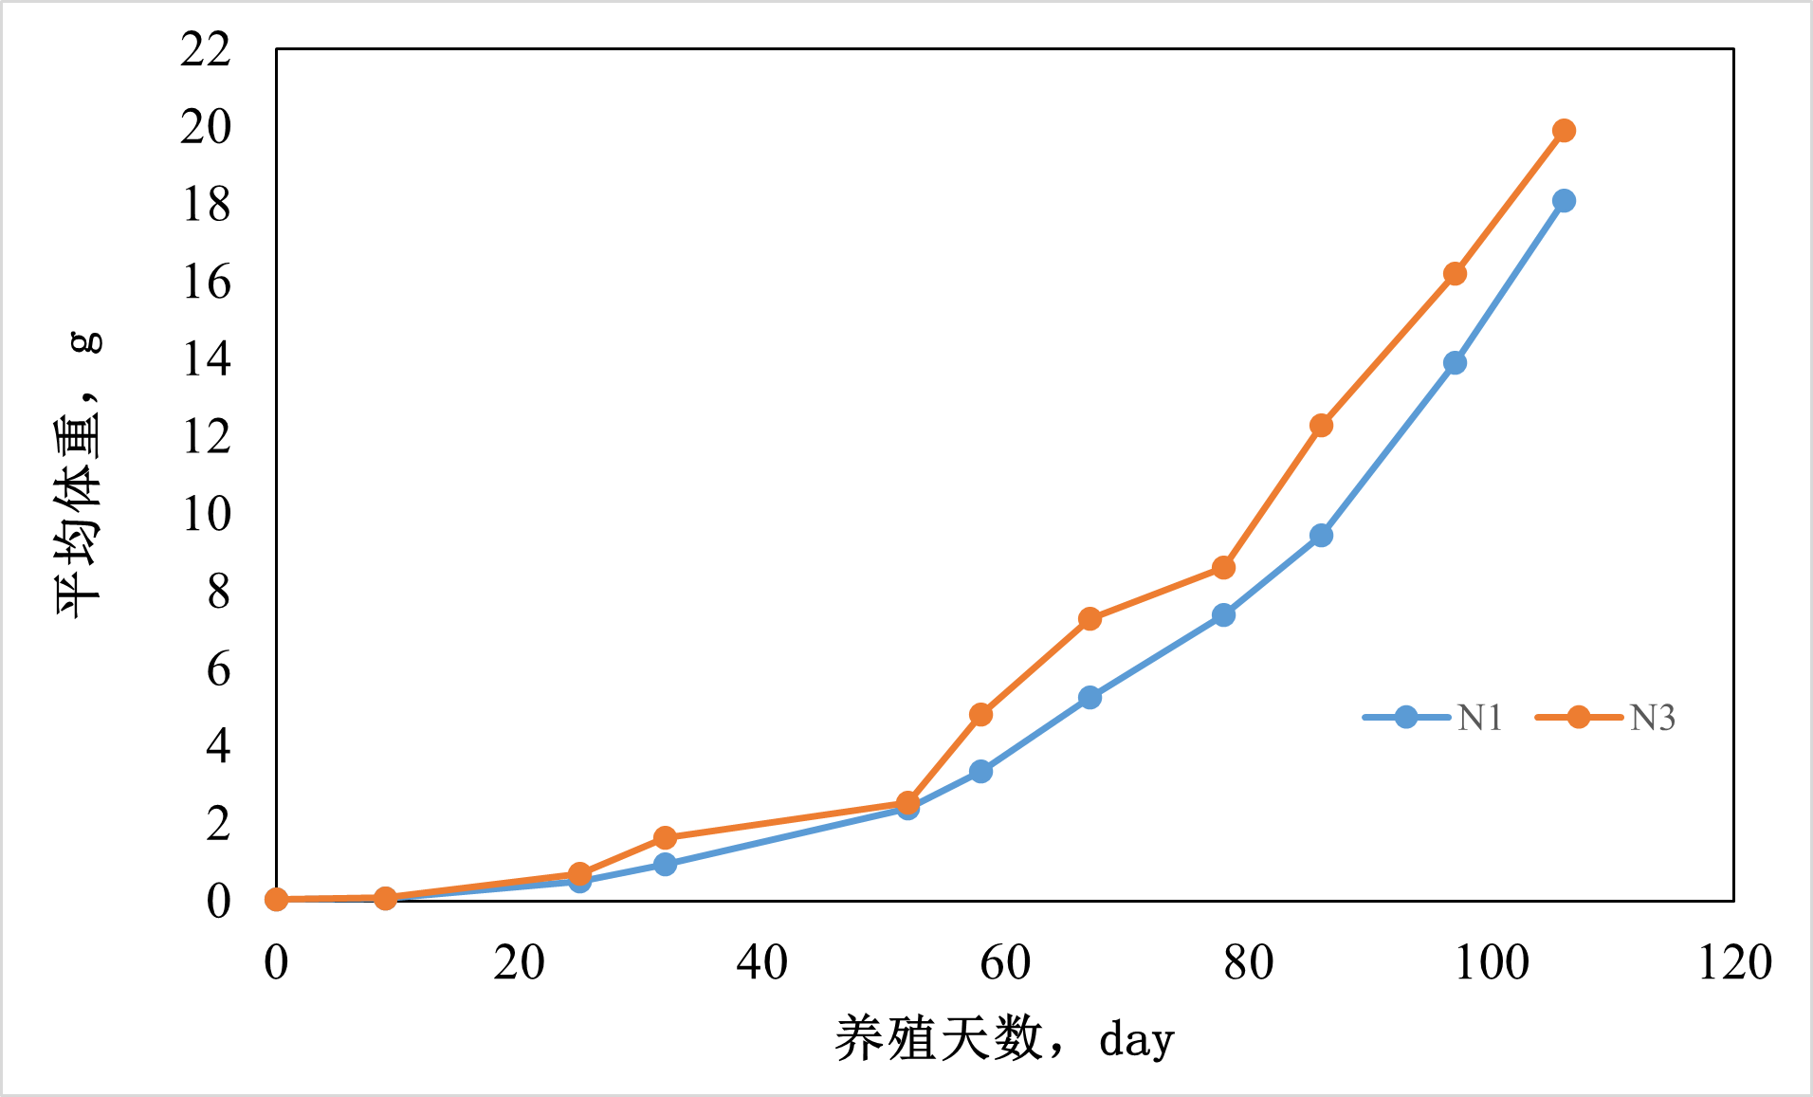

**Fig. 13 Mean shrimp weight gain, N1: Pool 1; N3: Pool 3**

The picture above demonstrates that after three months of breeding, the average weight of shrimp in pool one is 18.1 grams, and the average weight of shrimp in pool three is 20.3 grams, with the average weight reaching about 20 grams.

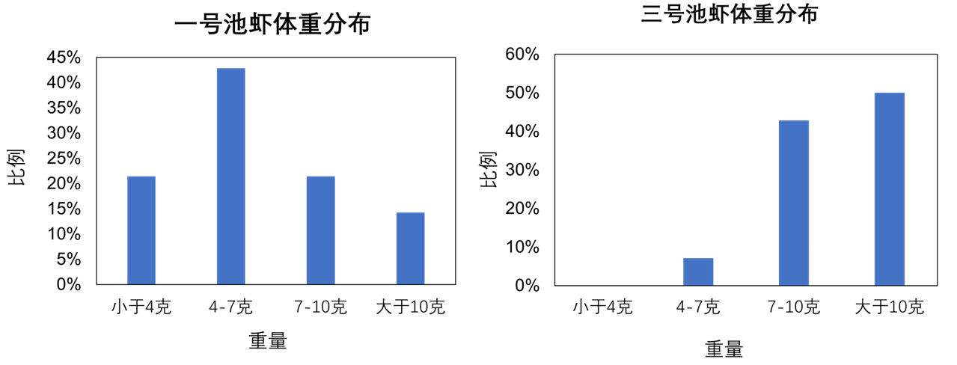

**Fig. 14 Distribution of shrimp weight in pool 1 and pool 3 at 80 days of culture**

However, the main due to the uneven size of the shrimp fry, resulting in feeding by the large shrimp grabbing small shrimp almost no food to eat and do not grow or even death. Harvest shrimp size is also uneven. The above figure shows the uneven distribution of shrimp size at 80 days of breeding. The average weight of shrimp in pool 1 was 7.08 g/pc; body length ranged from 7.0 to 14.5 cm. The smallest was 3.24 grams and the largest 17.99 grams. The average weight of shrimp in pool three was 9.58 g/pc; body length 9.0 to 12.0 cm. The smallest was 4.83 grams and the largest 14.31 grams. Because some of the more unevenly sized shrimp fry in some of the bags at the time of the arrival of the fry were put into Pool One for culture, thus the uneven size of the shrimp fry in Pool One was a little more serious.

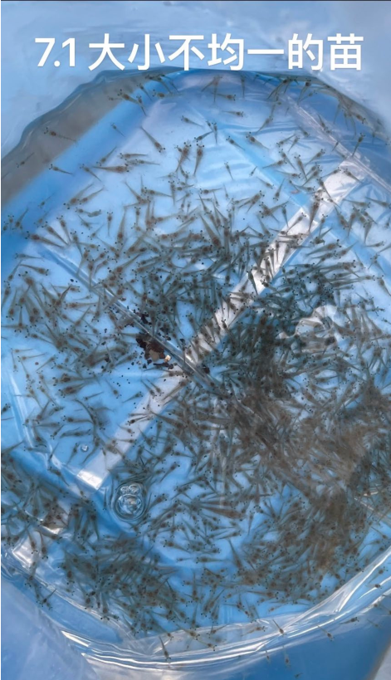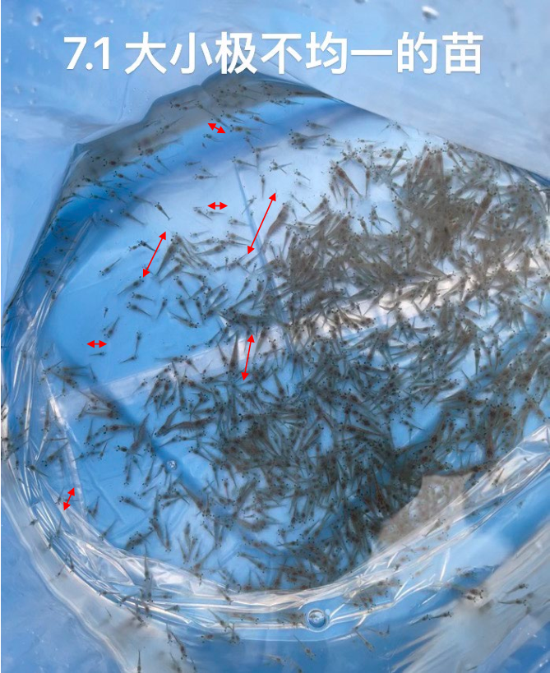

**Figure 15 Arrival of shrimp fry of different sizes on July 1, 2024**

The picture above shows what twenty bags of shrimp fry looked like when they arrived at the shed on July 1, 2024, with uneven sized fry. Each bag had about 1500 shrimp fry. Two bags were manually sampled for counts of 1,468 (+24 dead fry) and 1,520 (+17 dead fry) tails. The number is basically normal. Problems are: ① shrimp seedlings are too large to resist transportation, part of the death; ② shrimp seedling size varies greatly, seedling size ranging from 0.8 to 3.7cm. The breeding of the late stage will appear big, small shrimp seedlings almost no growth problems.

8.1.2 Water quality indicators (daily data)

During the culture process from July 1 to November 2024, no major water quality fluctuations occurred in pools No. 1 and No. 3, and ammonia was high at the beginning of the culture process and basically stable at the end. Ammonia in pool 1 was high at the beginning of the culture process, but basically stable at the end, with a value of 0 mg/L; ammonia in pool 3 was basically maintained below the standard value, with a value of 0 mg/L at the end of the process.Nitrite fluctuated a little bit, and could be basically maintained between 0 and 0.5 mg/L, which had no major impact on the culture. Nitrate concentration increased with the increase in the number of days of aquaculture, but nitrate has a small impact on shrimp. pH value is adjusted by adding lime milk, basically maintained in the appropriate range. Cultured water temperature from July, August, September to maintain between 28 ~ 31 degrees Celsius, the most suitable for shrimp growth, to mid-October water temperature began to decline, to November 10, the water temperature can be maintained above 20 degrees Celsius. Dissolved oxygen values fluctuate greatly, with the growth of shrimp and increased feeding, dissolved oxygen will gradually fall from 7.5 mg/L to about 3.0 mg/L. Consideration of how to increase the level of dissolved oxygen under high-density aquaculture is a key topic.

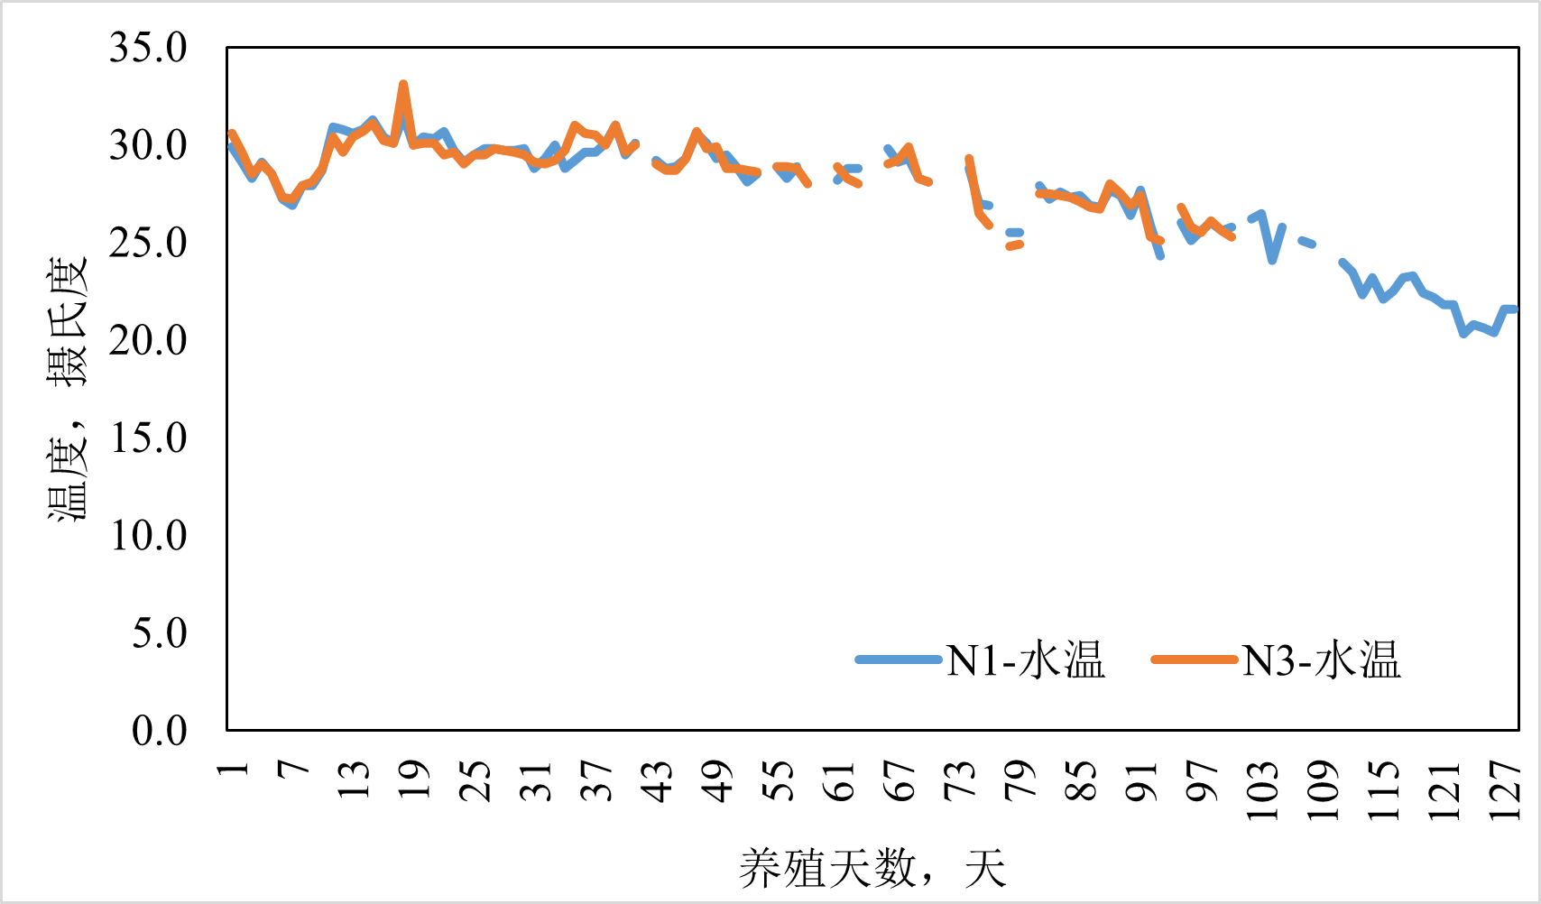

**Fig. 16 Variation of water temperature of aquaculture pools with the number of days of aquaculture, N1: Pool No. 1; N3: Pool No. 3**

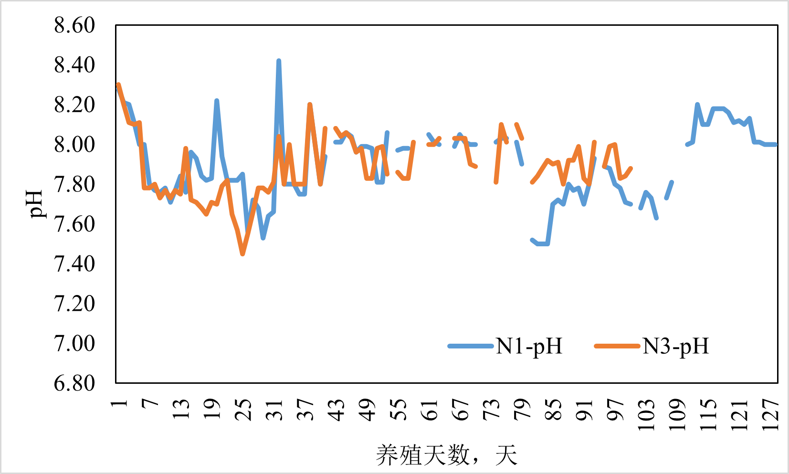

**Fig. 17 pH variation with the number of farming days, N1: Pool 1; N3: Pool 3**

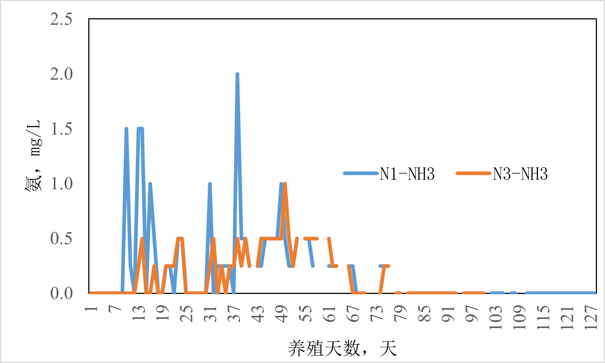

**Fig. 18 Variation of ammonia concentration with the number of farming days, N1: pool 1; N3: pool 3**

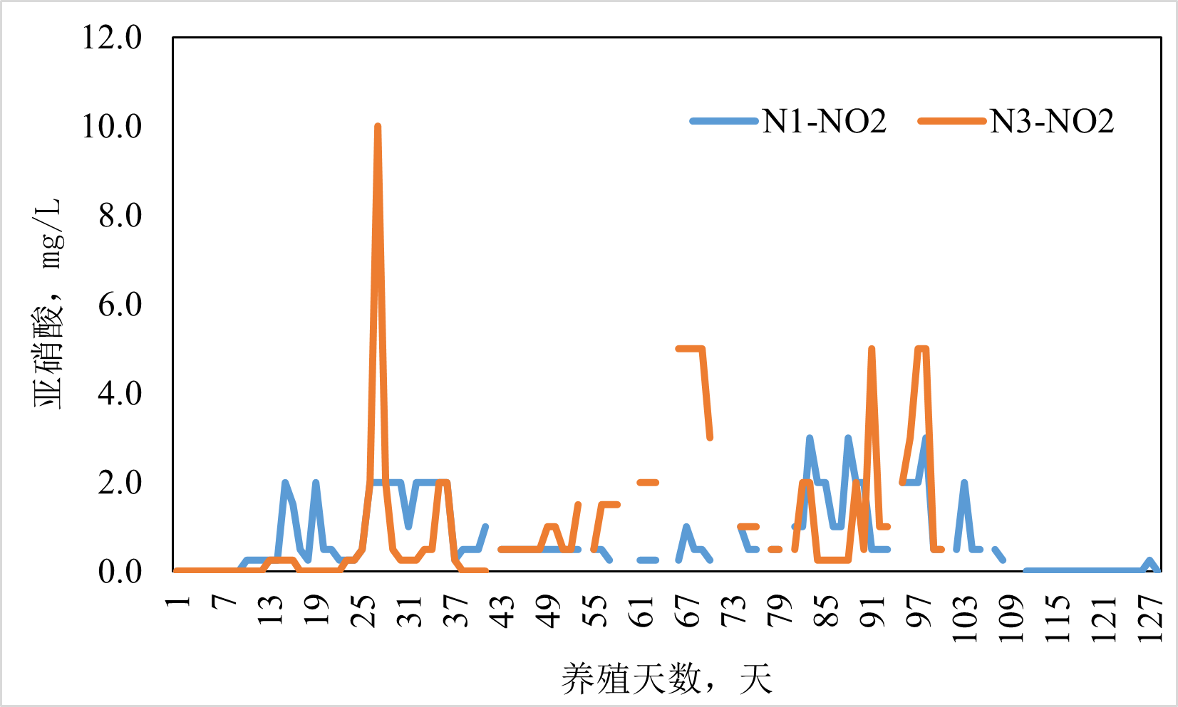

**Fig. 19 Nitrite concentration variation with days in culture, N1: Pool 1; N3: Pool 3**

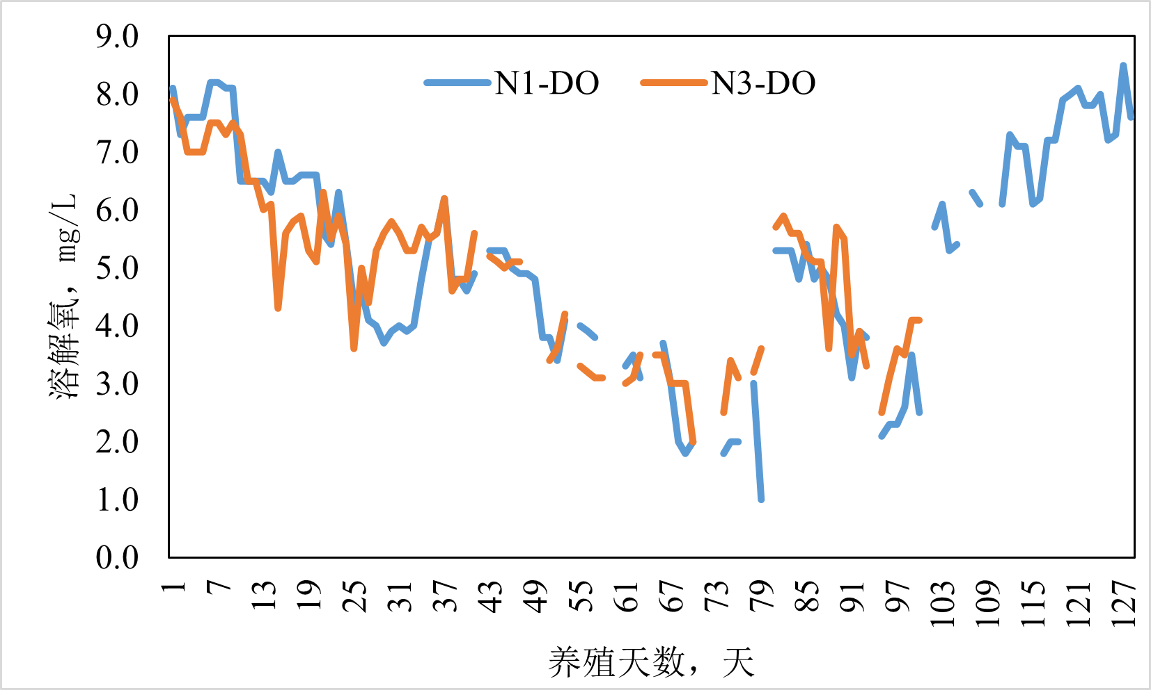

**Fig. 20 Variation of nitrate concentration with the number of farming days, N1: Pool 1; N3: Pool 3**

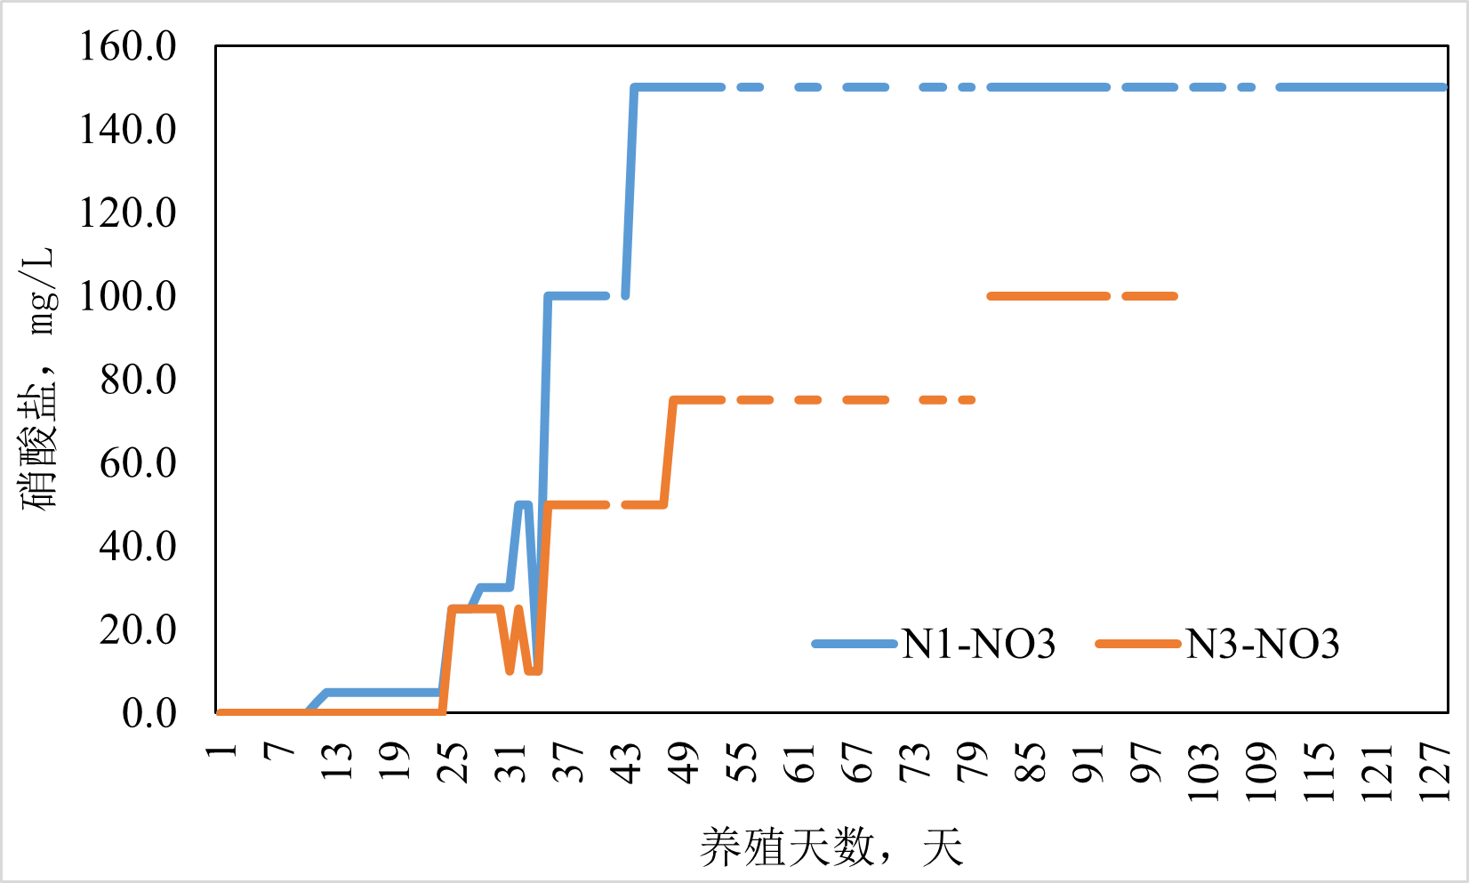

**Fig. 21 Variation of dissolved oxygen with the number of farming days, N1: Pool 1; N3: Pool 3**

Chapter 9 System upgrades and modifications

9.1 Adjustment of the system to increase farming densities

This breeding density is basically maintained at 500~1000 tails/square meter, which is a higher density than quite high considering that there is no water change for breeding. However, there are still some problems that cannot be ignored.

1. **Improve the efficiency of solid waste collection and discharge out of the farming system**

Physical filters can filter out solids above 70 microns (using a 200 mesh screen), but the key is how to increase the efficiency of concentrating solids in the pool into the physical filter and reducing the backwash frequency of the physical filter to reduce the amount of discharge.

Proper water flow design can concentrate dirt in the center of the pool, where it can be collected in the backwash physical filter. The pool water can be swirled up using a larger circulating water volume/suitable inlet angle, which can concentrate the dirt in the center of the pool, which can then be collected into the physical filter. Try to avoid the loss of kinetic energy for flow creation by various equipment in the pool (especially aeration equipment), which can cause flow creation to fail.

Use a dual-row system. The key to the dual-row system is a large flow rate of circulating water from the pool of the upper part of the water, this part of the water to avoid the physical filter, to avoid clogging of the physical filter and too frequent backwashing; small flow rate of circulating water to the bottom of the solids precipitated with high efficiency to bring out to the physical filters, which part of the small amount of water can be more than 90% of the solids precipitate out. Dual-row system can maintain a large total volume of circulating water (through the biofilter), so that the circulating water of the biofilter will not be clogged by the physical filter and lose its function; but also rely on the good dirt collection efficiency will be most of the dirt (through the small amount of water) concentrated in the physical filter and be filtered out.

Use as large a size as possible for physical filters. Other forms of filtration may also be considered.

1. **Improving dissolved oxygen levels in high-density aquaculture**

Increased aquaculture densities have placed extreme demands on the need for aeration to maintain high dissolved oxygen levels. Although a certain degree of low dissolved oxygen level will not lead to culture failure, it will certainly have an impact on the respiration, digestion and growth of organisms, so it is very important to maintain a high level of dissolved oxygen.

Dissolved oxygen in this culture may have been problematic due to high density and aeration efficiency that could not reach the oxygen consumption rate ; or it may have been due to the large amount of oxygen consuming microorganisms that proliferated in the water and consumed a large amount of oxygen. In a very small experiment during the middle and late stages of culture, it was confirmed that in 2 liters of water (turbid) without shrimp life, dissolved oxygen was also being consumed at a rapid rate (from 5.3 mg/L to about 0.5 mg/L in just 1 minute). The ability of a large number of oxygen-consuming microorganisms to consume oxygen cannot be ignored. This is also directly related to the rapid removal of solid waste, which in large quantities in the tanks will provide certain attachments and nutrients for the growth of microorganisms, resulting in rapid growth of microorganisms and even the formation of certain bioflocs (Biofloc Technology).

Biofloc technology is also an aquaculture technology that reduces water changes between earthen pond aquaculture and fully recycled water factory farming, but it requires maintaining a balanced relationship between bioflocs and aquaculture organisms and may cause problems such as earthy odor. It has no relationship with this recirculating water factory farming that can be learned from.

The use of Oxygen Cone can increase dissolved oxygen levels up to 20 mg/L and reduce the number of conventional aeration stones/discs in the tank. Dissolved oxygen levels in the water can also be increased using micro-nano-bubble technology.

9.2 Adaptation of new designs

The selection and design of the physical filter is very important. Consideration can be given to connecting several tanks together and providing a more complete physical filtration, biofilter and disinfection and sterilization facility. Several tanks can share a common life support system for ease of maintenance and troubleshooting. However, for safety reasons, it is important to have at least one other set of equipment on standby, which provides the possibility of immediate switchover in the event of failure or poor operation of one of the modules in one of the systems (physical filters, biological filters, pumps, air pumps, etc.). It is also possible to have one set of systems activated during maintenance. This may improve the stability and reliability of the overall operation. For example, for every five 20-ton breeding tanks in parallel, provide one life support system with a design capacity of 100 tons and another identical system on standby. The costs and benefits of such operation can be calculated and considered.

9.3 Environmental protection and energy conservation measures

9.3.1 Wastewater recycling

Considering a more water-efficient option for current conditions, the solid waste filtered out of the physical filter could be leached dry, and the upper clear water continues to be returned to the biofilter and treated and returned to the breeding pond. The remaining solid waste contains very little water and can be composted for volume reduction. This can be done with almost no replenishment of new water except for evaporation, and can even reduce wastewater discharge to zero.

9.3.2 Energy conservation programs

* The use of solid waste such as shrimp manure for biogas fermentation can generate energy that can supply the daily electricity consumption of the greenhouse;
* The use of solar power panels can generate electricity for the use of the shed;
* Using solar energy to heat water saves on the energy consumption needed to heat water during the fall and winter months;
* Good insulation of breeding ponds and insulation of greenhouses can result in significant energy savings.

bibliography

Michael B. Timmon, Songming Zhu. 2021. recirculating aquaculture systems (5th ed.). Hangzhou: Zhejiang University Press.

Cai, S. L., Huang, X. X., Liu, H.. 2015. Introduction to Aquaculture. Beijing: Ocean Press.

Li S, Zhu WM, Zhou M. 2018. New Technology and Examples of Efficient Culture of South American White Shrimp (Litopenaeus vannamei). Beijing: Ocean Press.